**Atlassian – JIRA**

Jira – which is widely used now for mainly Test management, Issue Tracking (like story, tasks etc.), Agile project management and Defect management which is a proprietary web based product developed by Atlassian. It helps the project manager to stay on top of what is happening in the project and helps to assign the task, monitor the work and progress of the project. Jira supports most popular agile environment and has a great customized dashboard depending on the team size, Type of Project, and has intuitive search features.

The Three main packages of Jira are

1. For Projects that contains Issues – Jira works as a bug Tracker.
2. For development teams – contains issue tracking and Agile project management (Add ON) – (Jira + Jira Agile).
3. For Service Desk – Contains issue tracking and service request (Add on)

**How to Install Jira**

As Jira is not an open source we need to buy from the Atlassian site but we will be having a free trial version for a month and Atlassian is offering different price range depending the Team size of the company to host it in Jira cloud service. As we are working with downloaded version, the entire installation process may take around 15 to 20 mins’ time and configuring database is the longest part in it.

To download the Free trial version please visit: <https://www.atlasian.com>

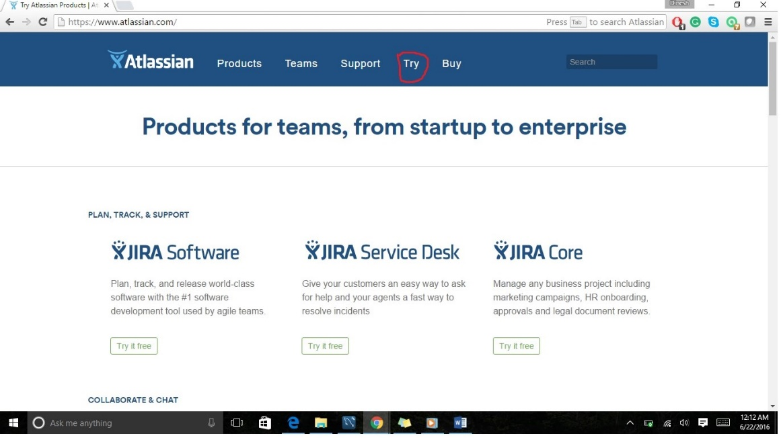

And please go head and click the try button which is available on the head section of the page.

To Download the Jira software and host it on our local server for more customization and control please follow the link.

<https://www.atlassian.com/software/jira/download>

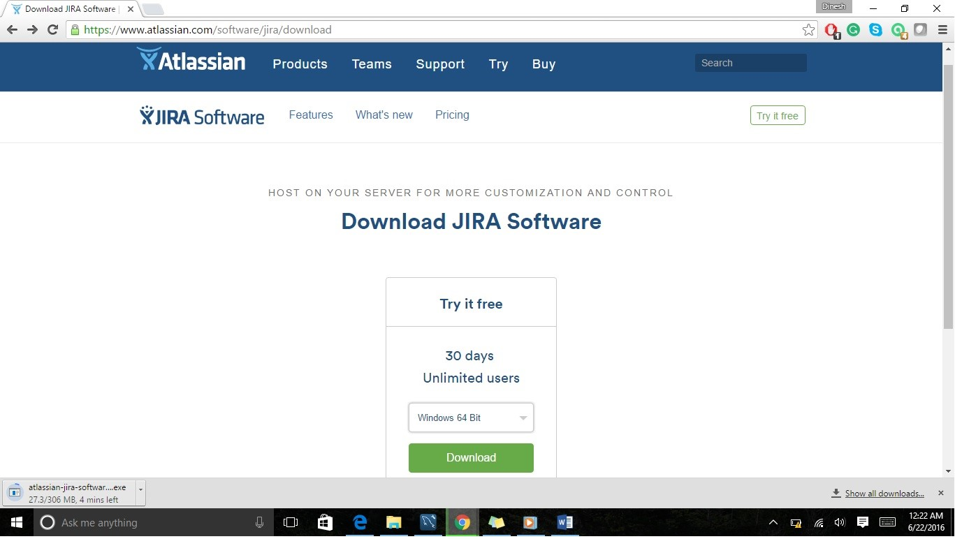

Please select the of your location machine and download the exact version. As my system is windows 64 – bit, I’m downloading it. There other option available for Linux, OS X.

Once it is downloaded, go head and double click on it and the installation process starts.

Step1: Click Next

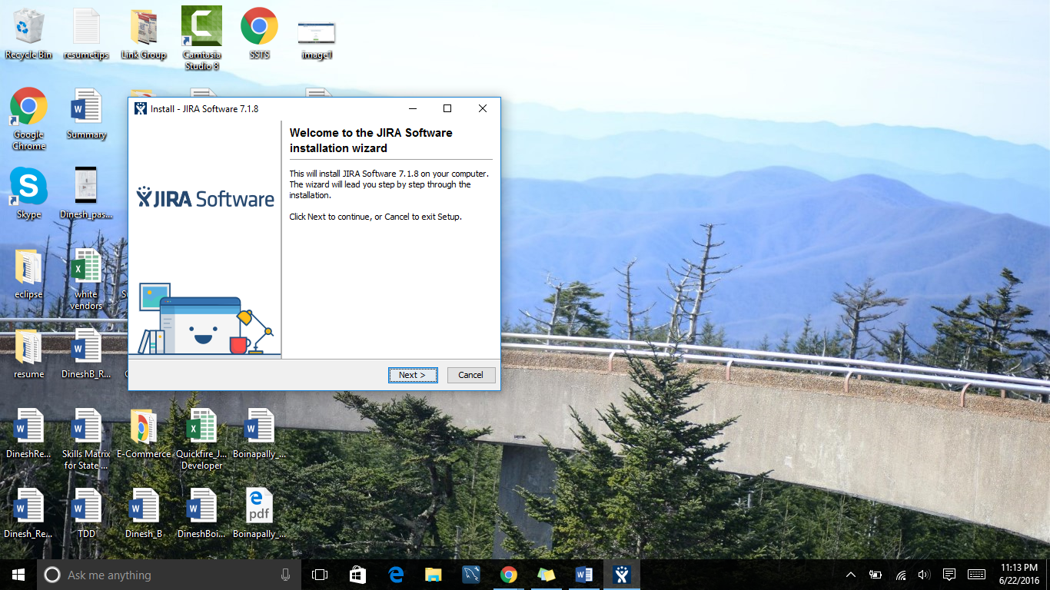

Step2:

It will be having three options. If we are not sure what settings, we need then going with express Install is good option but if we want install Jira on specific port and most the customized installation then choose the second option i.e., custom Install. Since I don’t have any system installed so I’m going with the second option.

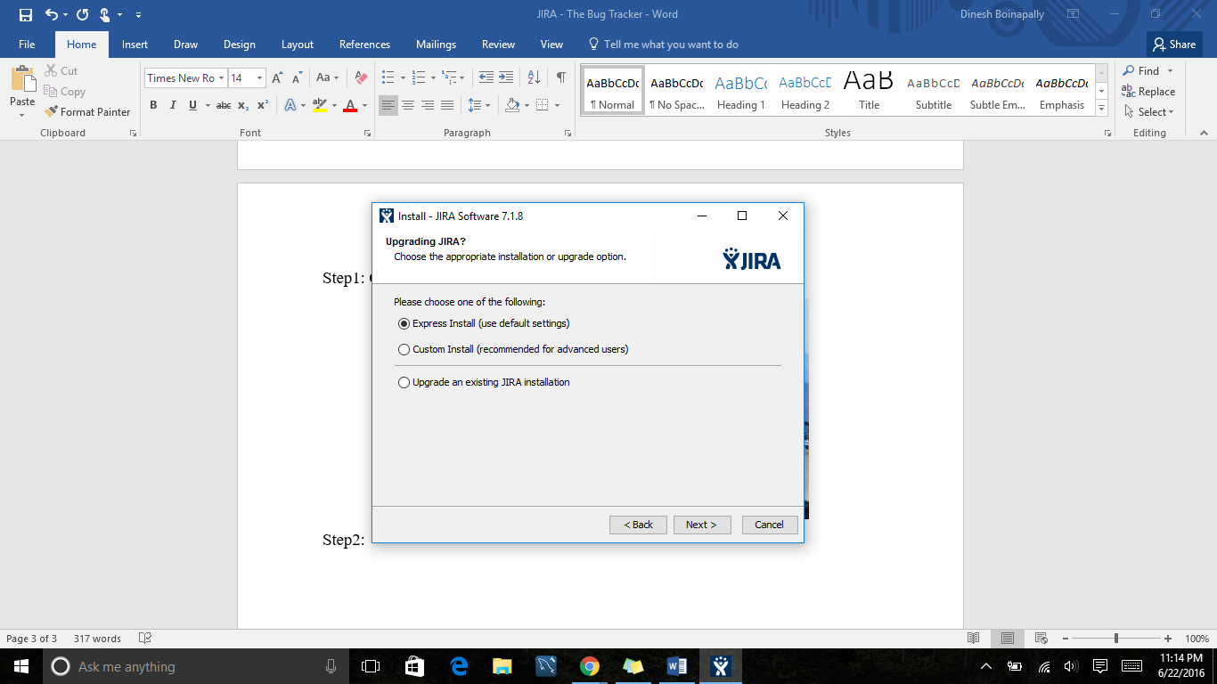

Step3:

Here the information will be provided about in which driver the Jira is installing. Basically the default driver is C: Driver.

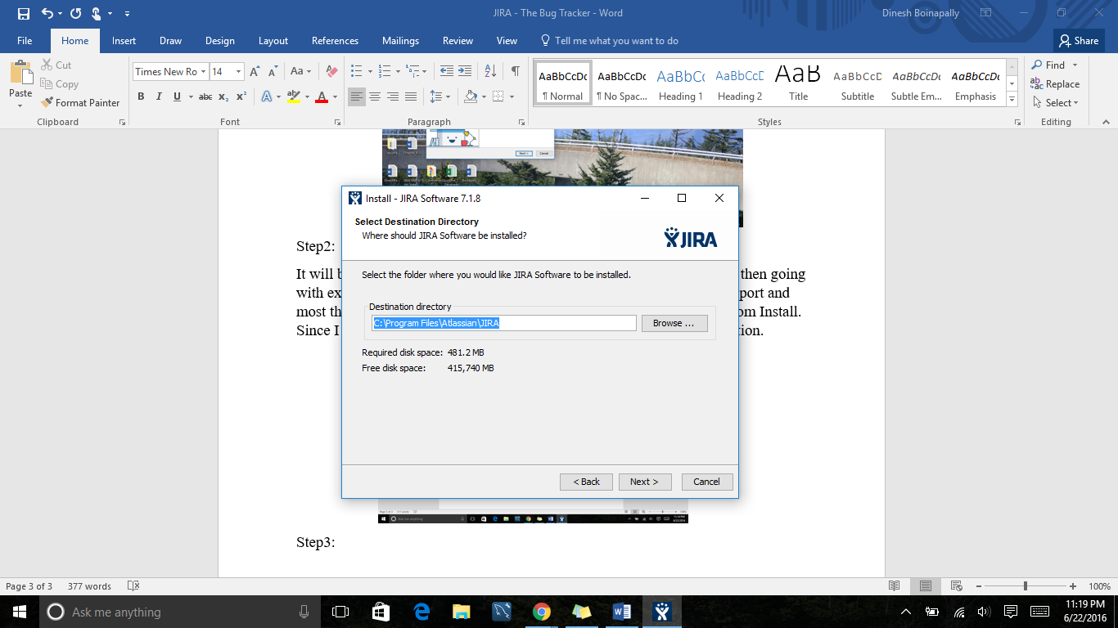

Step4:

Default location of software data.

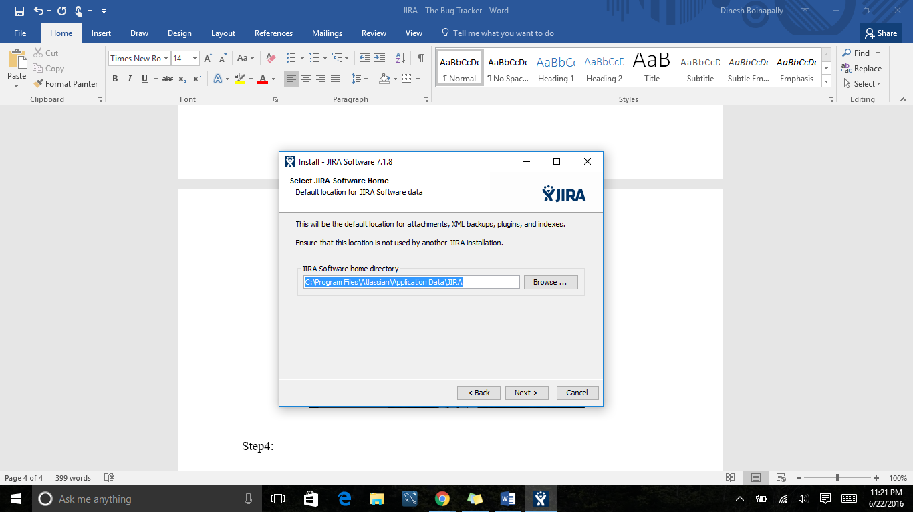

Step5:

The Port numbers where the Jira will be installed. In basic if the local computer is having Tomcat server installed in it then the port number of it will be 8080 by default. As I work on development process using Java platform, Tomcat server is installed in my local desk at port 8080 so, I don’t want to disturb the server so selected custom value and installed it in port 8083. Sometimes the control port looks busy and gives error so try changing that. To know which ports are listening and which ports are established please go to the command prompt and enter

“netstat -an” this will give the complete port numbers listed.

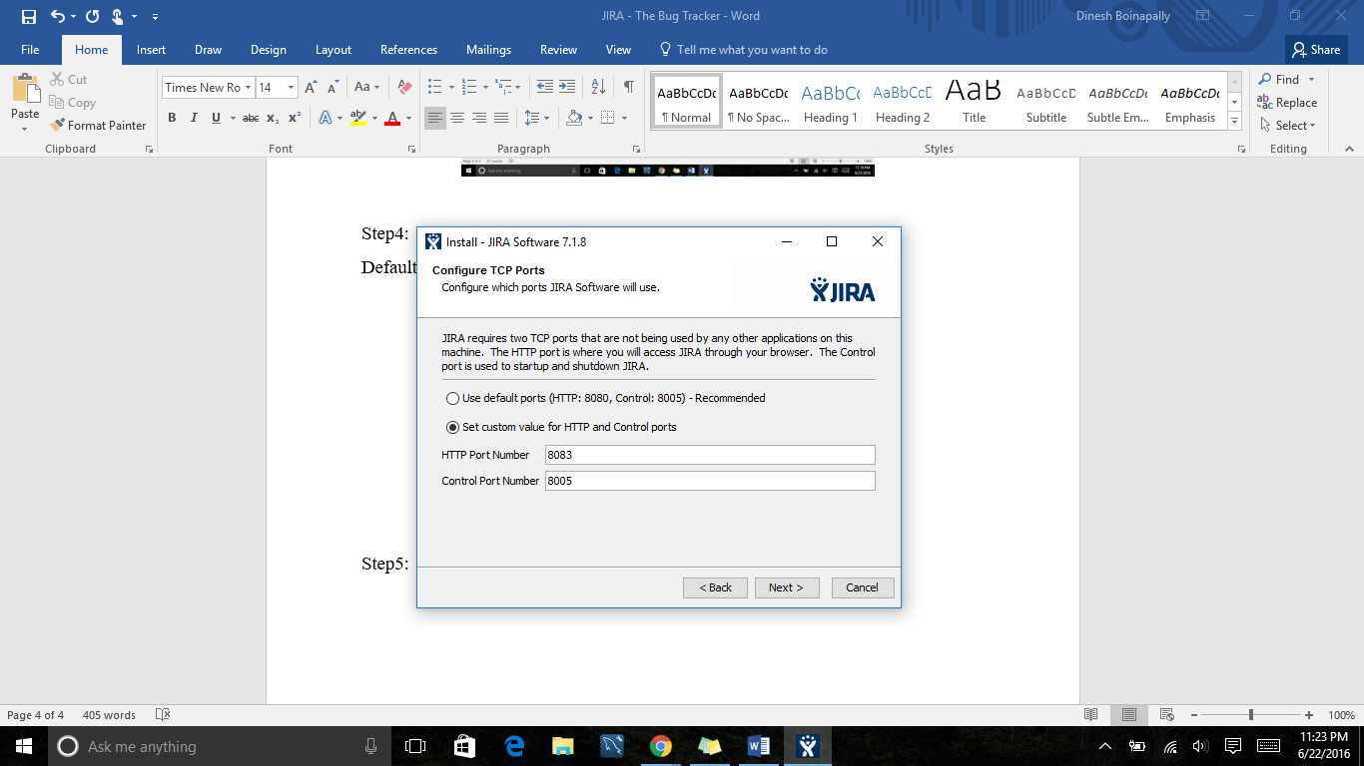

Step6:

Please check the option available to start the Jira in the background whenever computer restarts. If you don’t need it, please uncheck the option. So you need to start it manually.

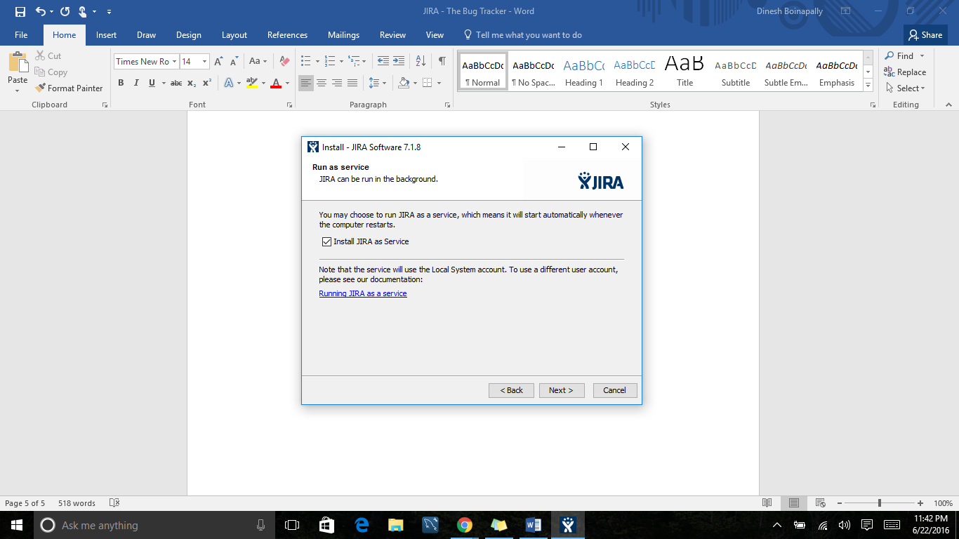

Step7: This will start the Installation process. This is the first part of installation and the second part of installation requires the JIRA account.

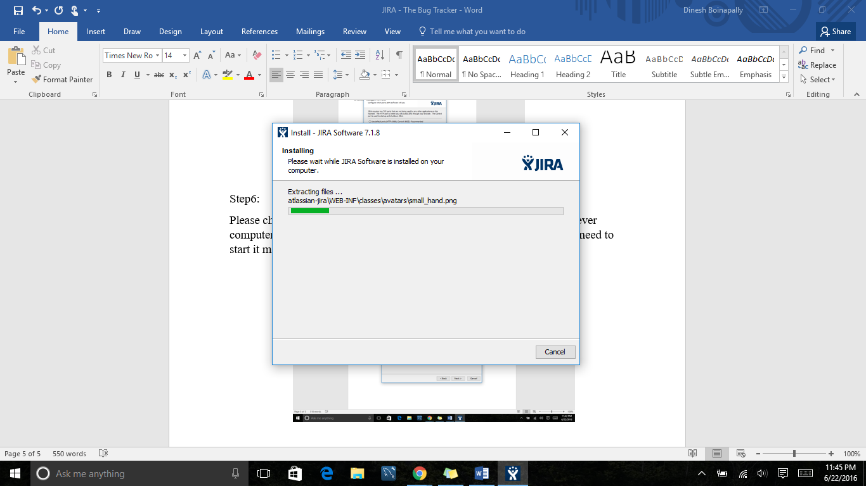

Step8: Please got to the Atlassian.com and create an account for free.

Step9: Once you click on the finish button it will redirect and opens the browser.

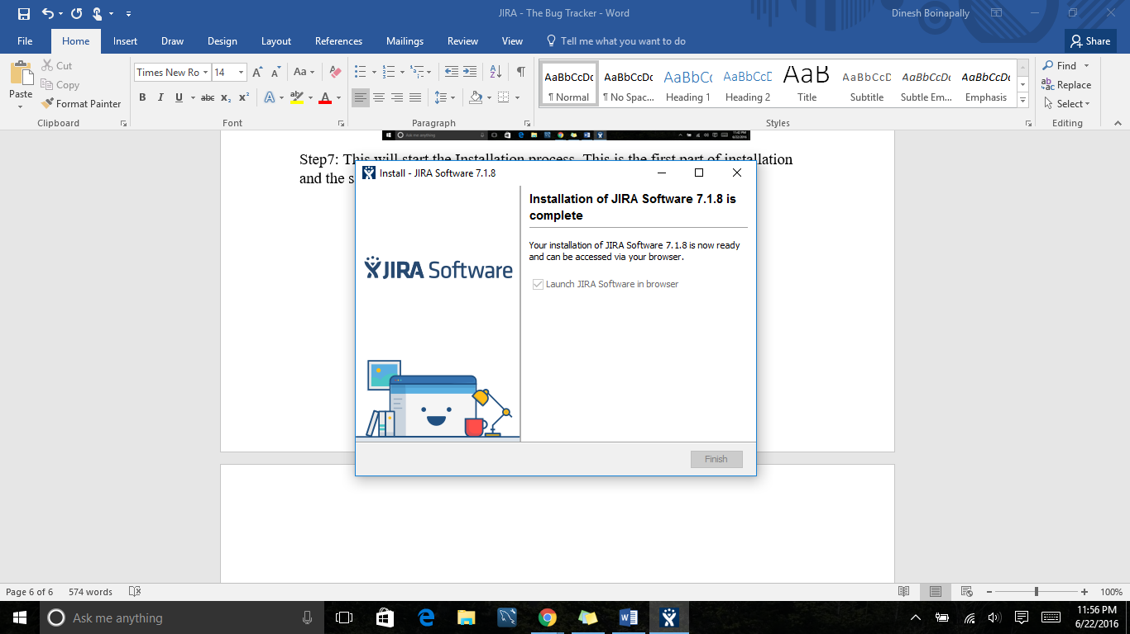

ii. It opens the browser and shows Jira setup and activate the evaluation version using the account the created. It takes some time if we are doing for the first time and shows the welcome page. As I’m working with it so I’m selecting the second option that is I’ll set up.

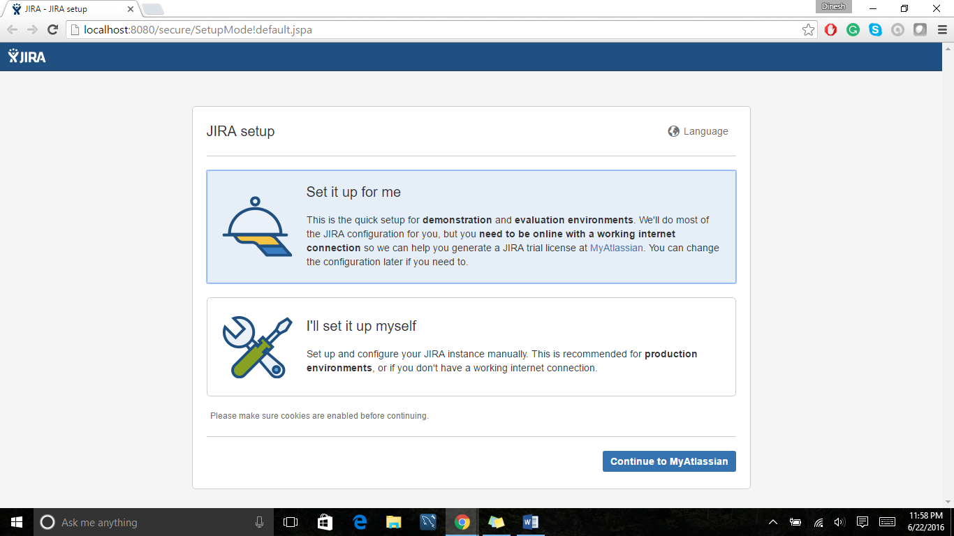

Step10: Then If we are working with production purposes the need to choose my own database but as we are working with it for evaluation process so just choose the built in option. It takes little while to because it works with setting up the database.

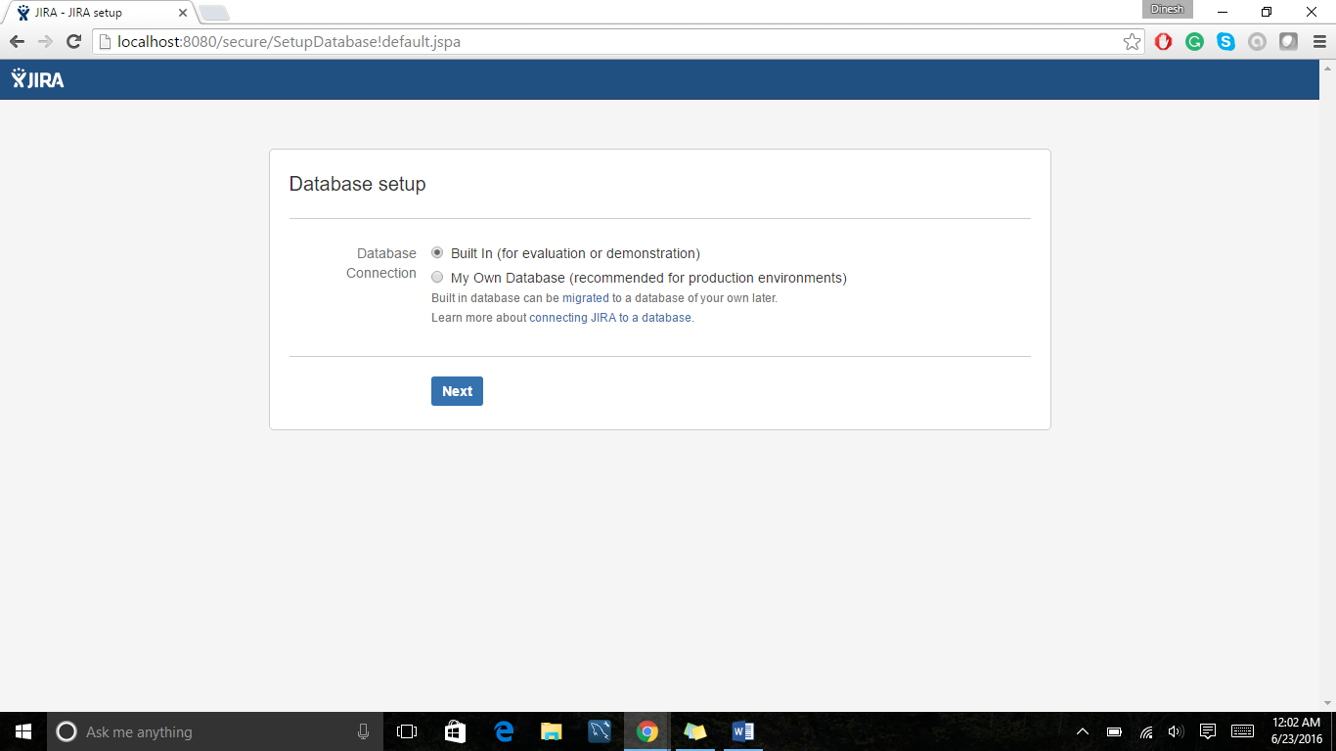

Step11:

Now we need to set up the properties like company name, public or private. Please choose the company name according to the requirement. In my case I’m choosing software mentor and public.

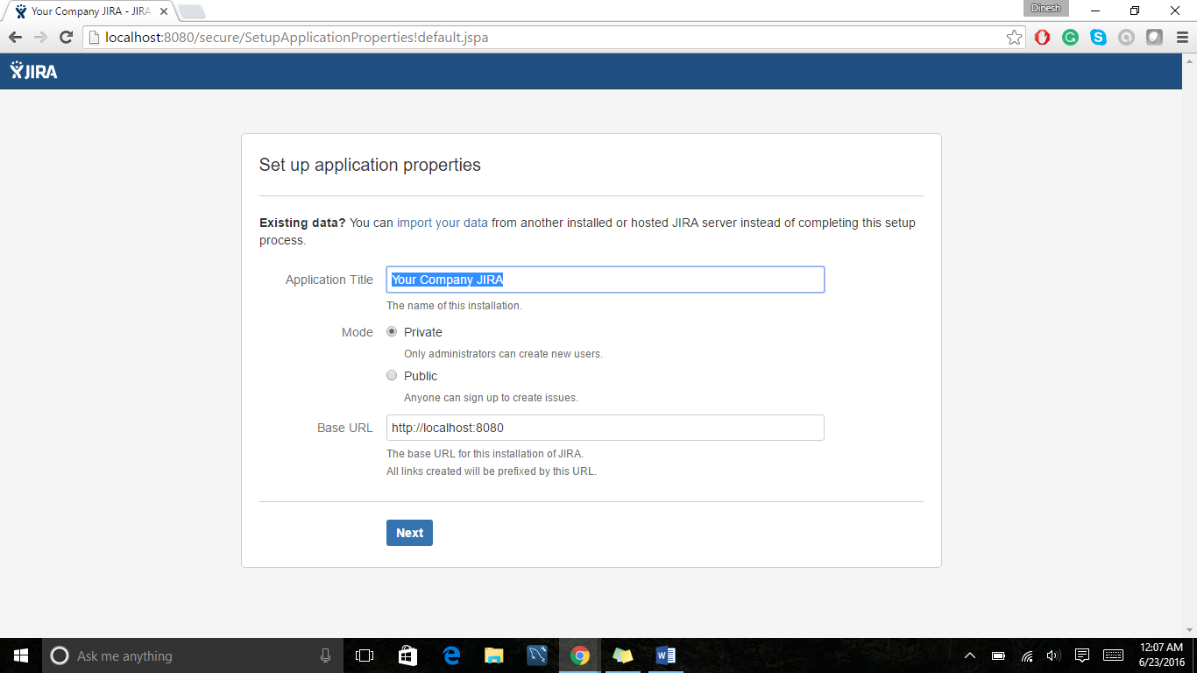

Step12: click next it will ask for “License Key”. This is where you need to Atlassian account to activate the JIRA. Generate the Trail version License key.

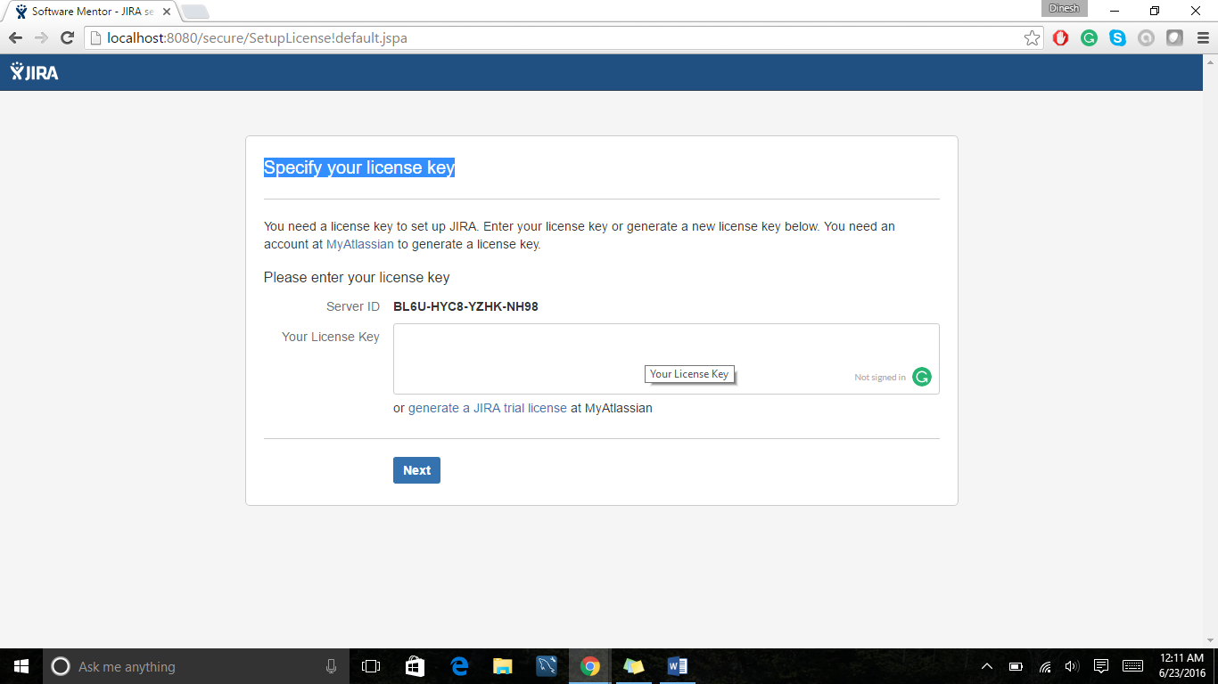

Step13:

Set up the Administrator details of a person for the project. I’m providing my details in my case for showing the example.

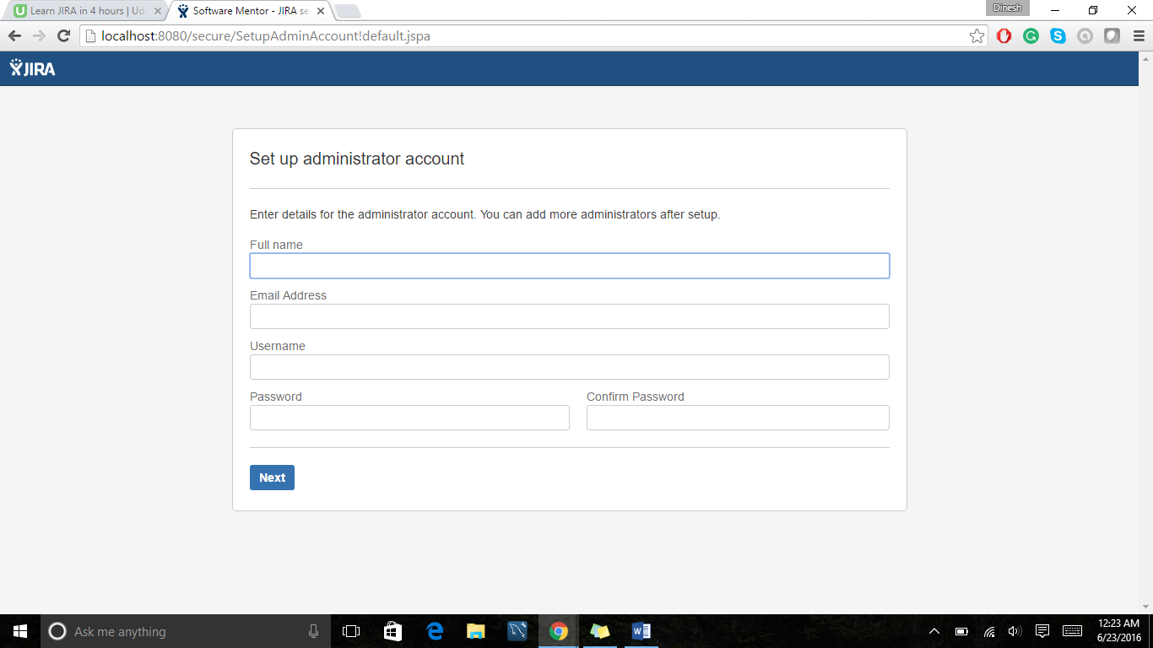

Step14: Its asks for email notification service. If you have any SNS and SES on the server please mention it by choosing “Now” option to get the email notifications. Right now I don’t have any so choosing the other option.

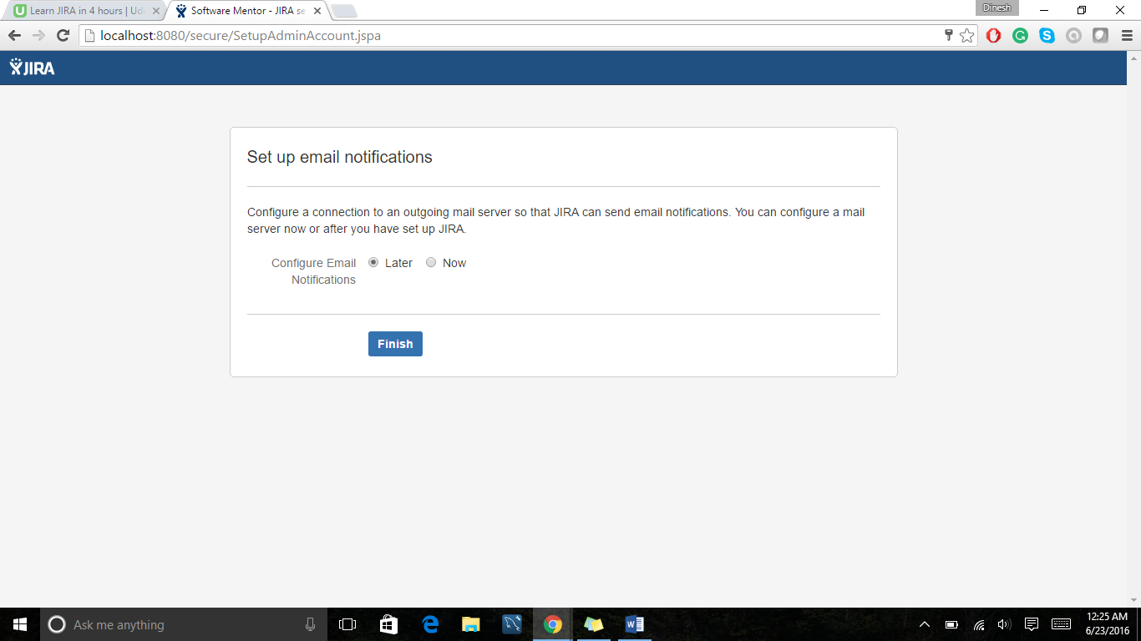

By clicking finish, the installation process of it is done and it opens the JIRA dashboard.

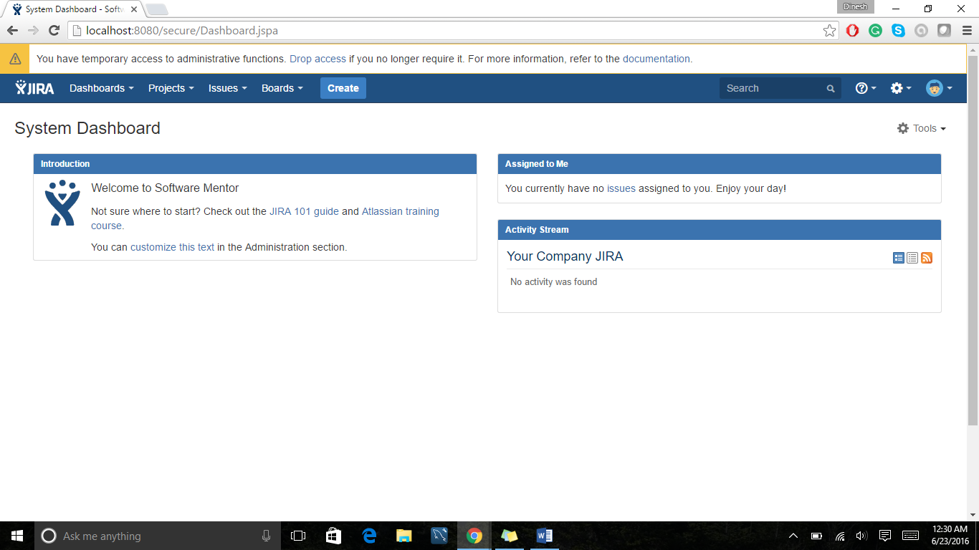

Now let’s work Jira tool by creating the project and working with Defect management and Issue Management in Jira and let’s focus about how to create Jira Agile for creating agile projects and boards. So Let’s start working on it without any late….

**How to create a project?**

To create a project in Jira please go to the top of the page and choose project option to create a new project. Issue management will not be shown until you have at least one project. Once start working on creating the project it shows different types of options available. In my case I’m choosing basic software development project as a developer.

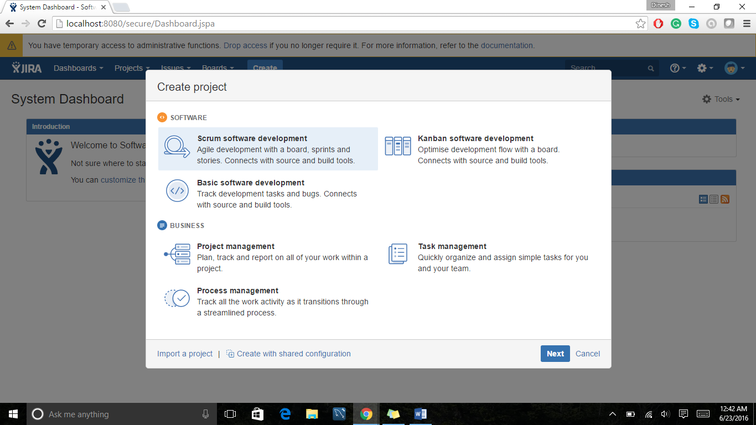

After selecting the basic development project, it shows

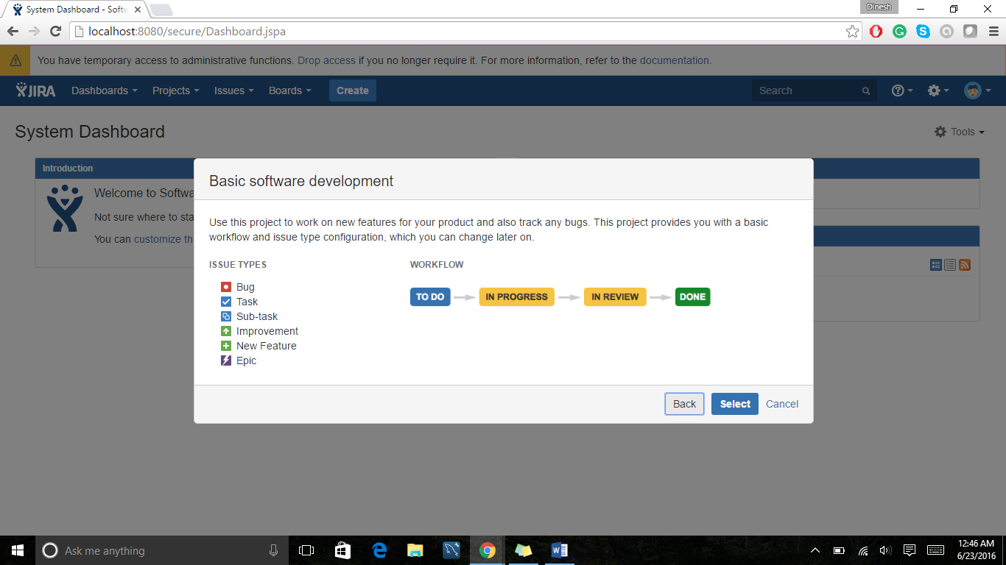

Hit Next, then it asks for the name of the project

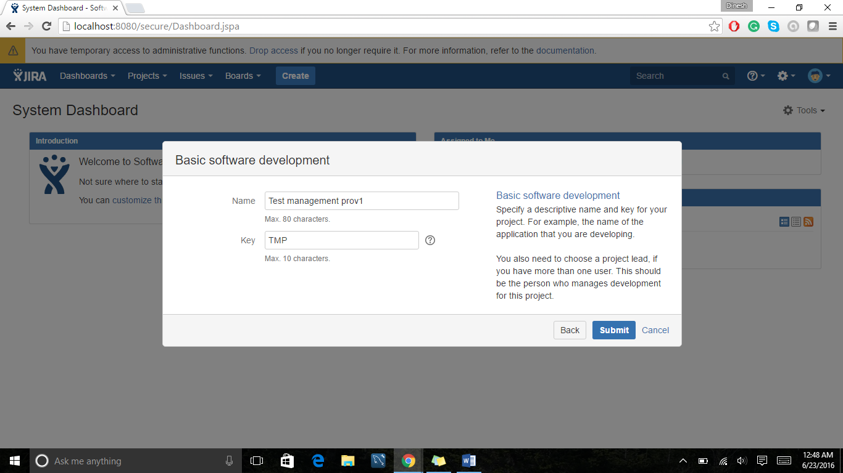

To work with agile Jira, please go ahead choose agile development project, as this option is an add -on it asks for the permission to download and install. So once you download and install it, new tab will be added beside issues tab with name agile on it.

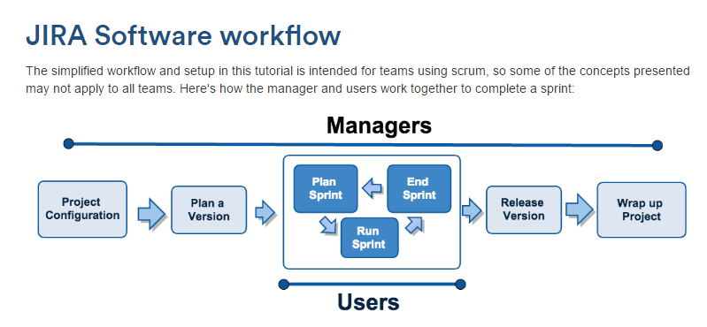

As Agile project comes as an add on similarly now let’s work with how to install Zephyr add on in Jira and how to enable test management in Jira. So in order to install it just go ahead and google it and choose Zephyr for Jira | Atlassian marketplace. The link to download it is

<https://marketplace.atlassian.com/plugins/com.thed.zephyr.je/cloud/overview>

and click try it for free option. Just go head and download it and now go to your Jira account and click on your user profile button then go to the Atlassian market place. On the left hand side, you can see the option manage add on. Choose manage add on and upload the downloaded file and install it. Once you done with this process you will be finding a test tab on your system dashboard. So now you can work with many functionalities.

How to Create adding users, groups and roles in Jira:

To perform these tasks, we need admin password but since you have already installed. Got to the template and select the user management tab. Here i8t will be asking for the administrator key for security. Please provide the details.

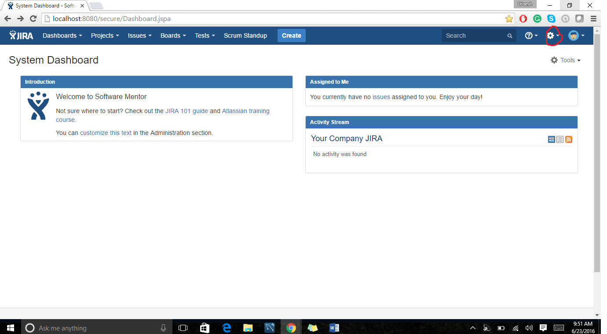

After providing the user management details the next step is it will open a new page where there will be an option for adding a new user, click on that start creating a new user.

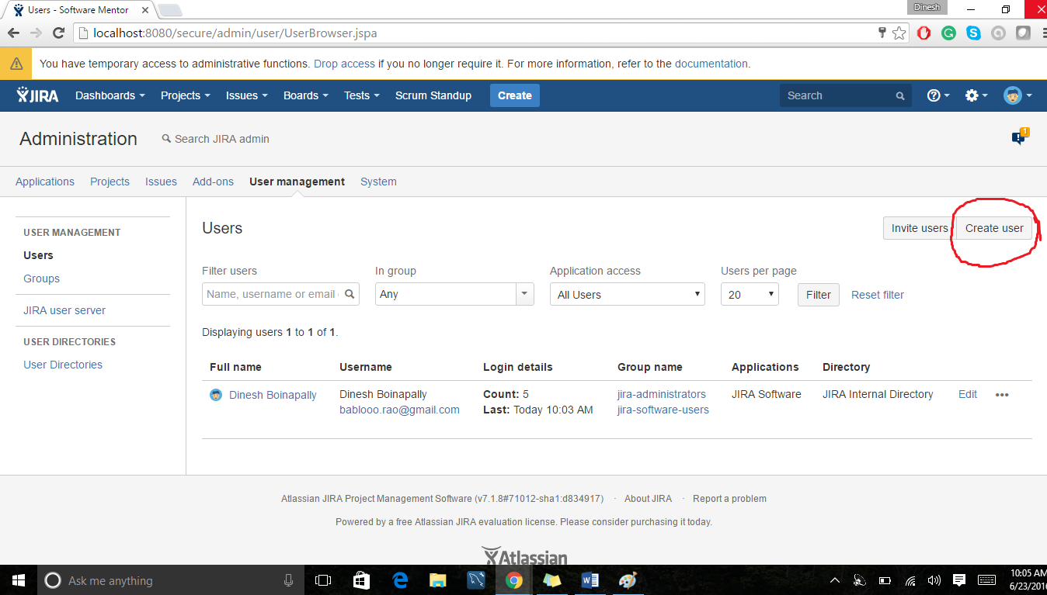

I have created a new user with name Dileep Rao. During the user creation time it asks for email address, full name and password. There will be one more option send notification to the user, this will work only if you have enabled SMTP notification service on server.

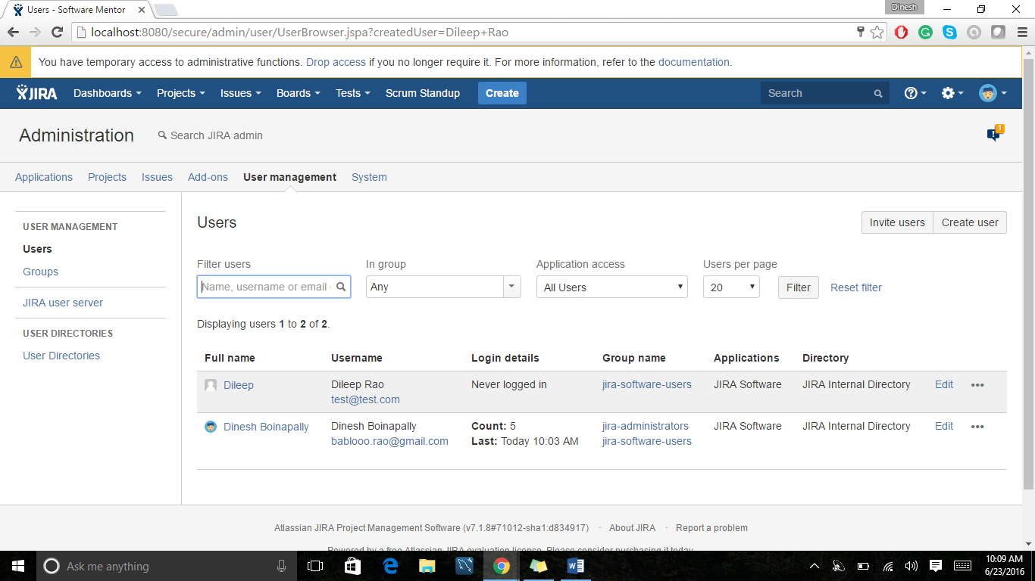

This is the user’s account information. The administrator can view all the user statistics like login count, last time login etc. If we want to delete the user go to the actions tab and you can find the option to delete it and also change the group of this user, password of this user.

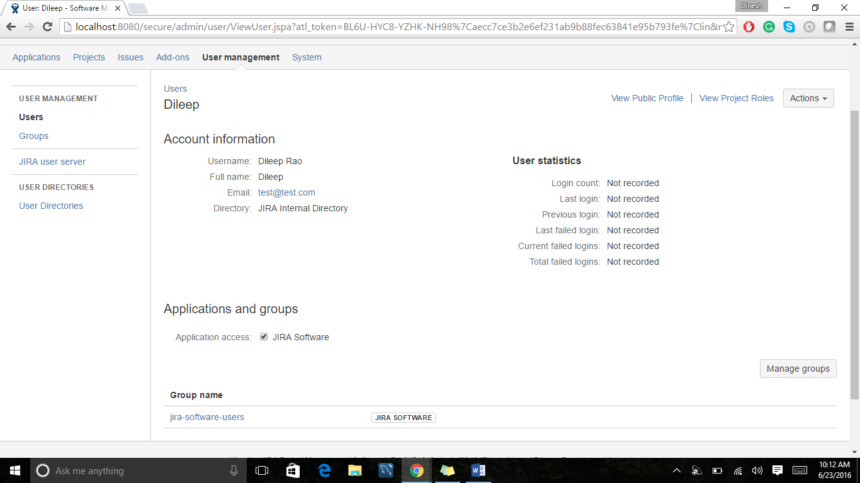

To create Groups, go to the groups under user management which is there on the left hand side and select groups tab. I have added a new group and named it as Jira-ba.

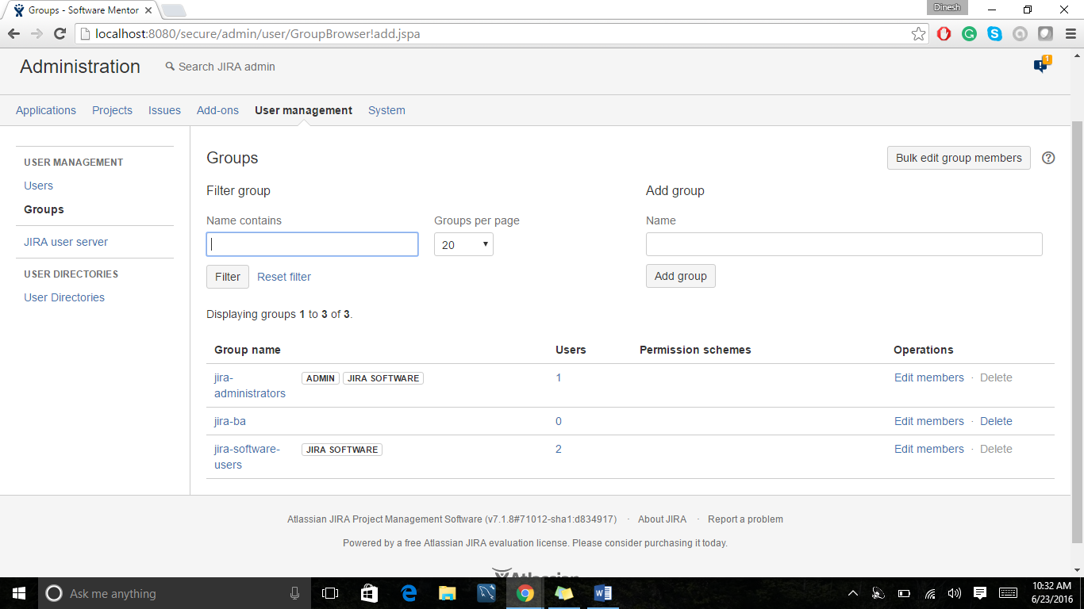

To add the role please go ahead and the search Jira admin for creating a role by using the keywords – Role. Search it if you don’t find any option below groups tab.

So once you are done, a role will be created and you can add special permissions, users to the role by selecting the manage default members of it.

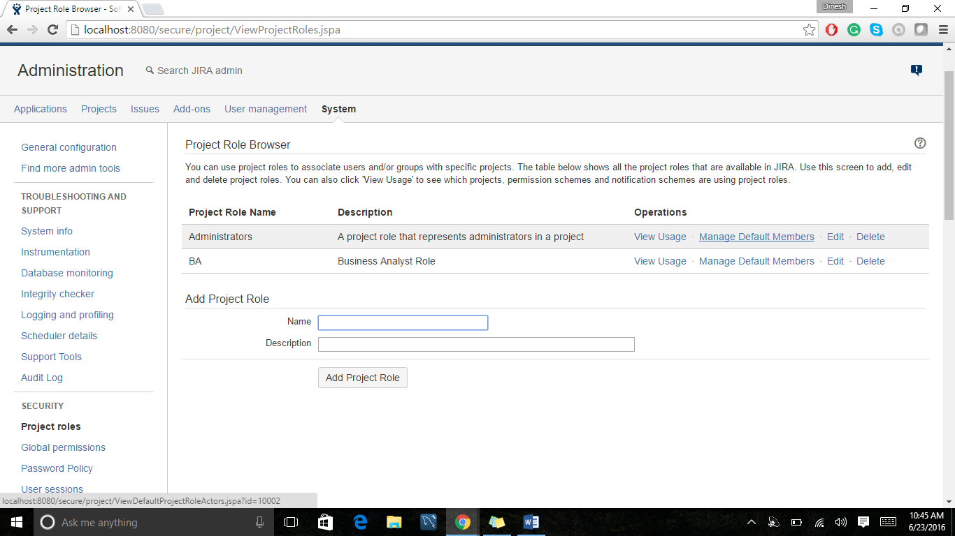

So once you click on the manage members, a new page will be opened showing the directions to add the users. Click on the edit option add the user you have created before.

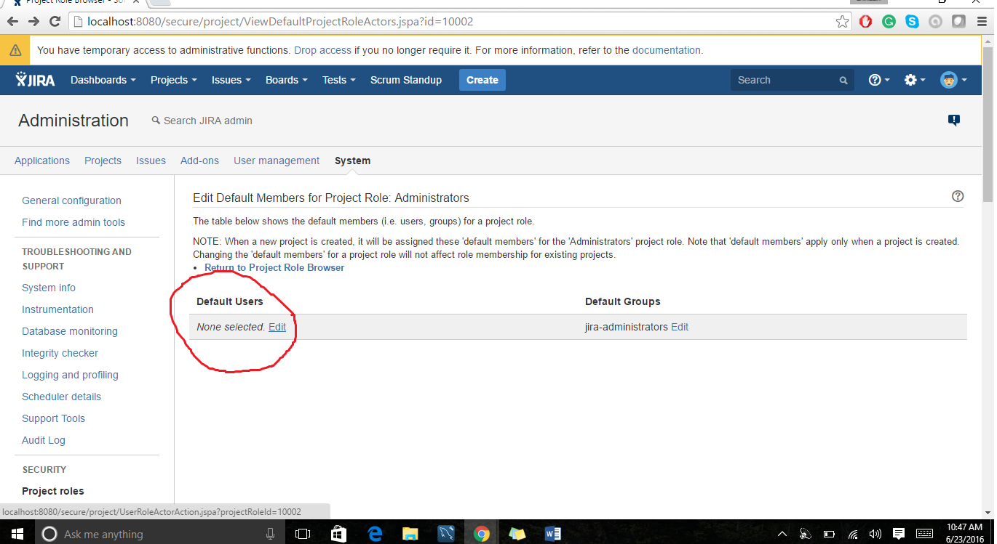

**Now let’s work with Dashboard**

1. How to manage the Dashboards and gadget.

So let’s create a new Dashboard and start working on it. In order to create a it there are two ways of doing it. Click on the dashboard tab and choose manage dashboards and from there create a dashboard and the other way is by tools options to create a dashboard.

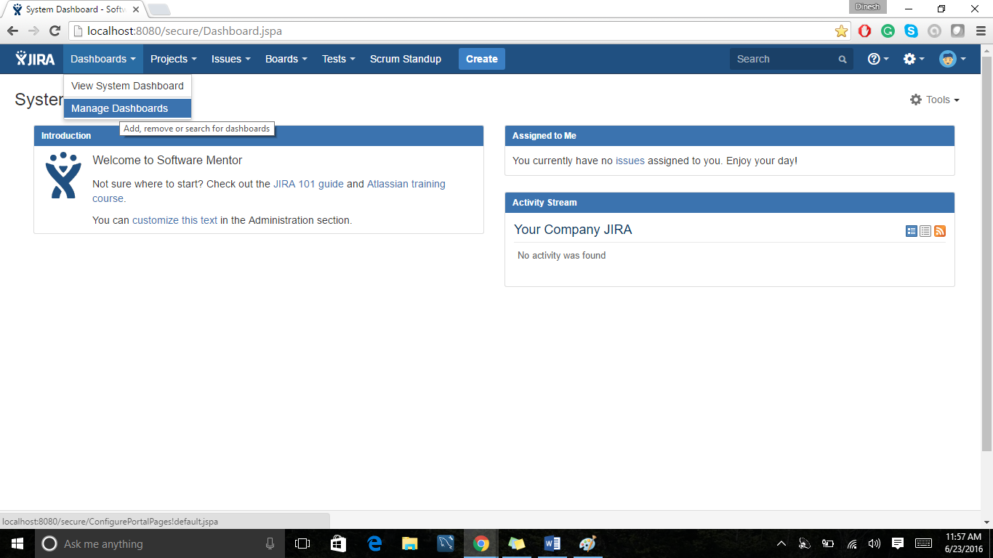 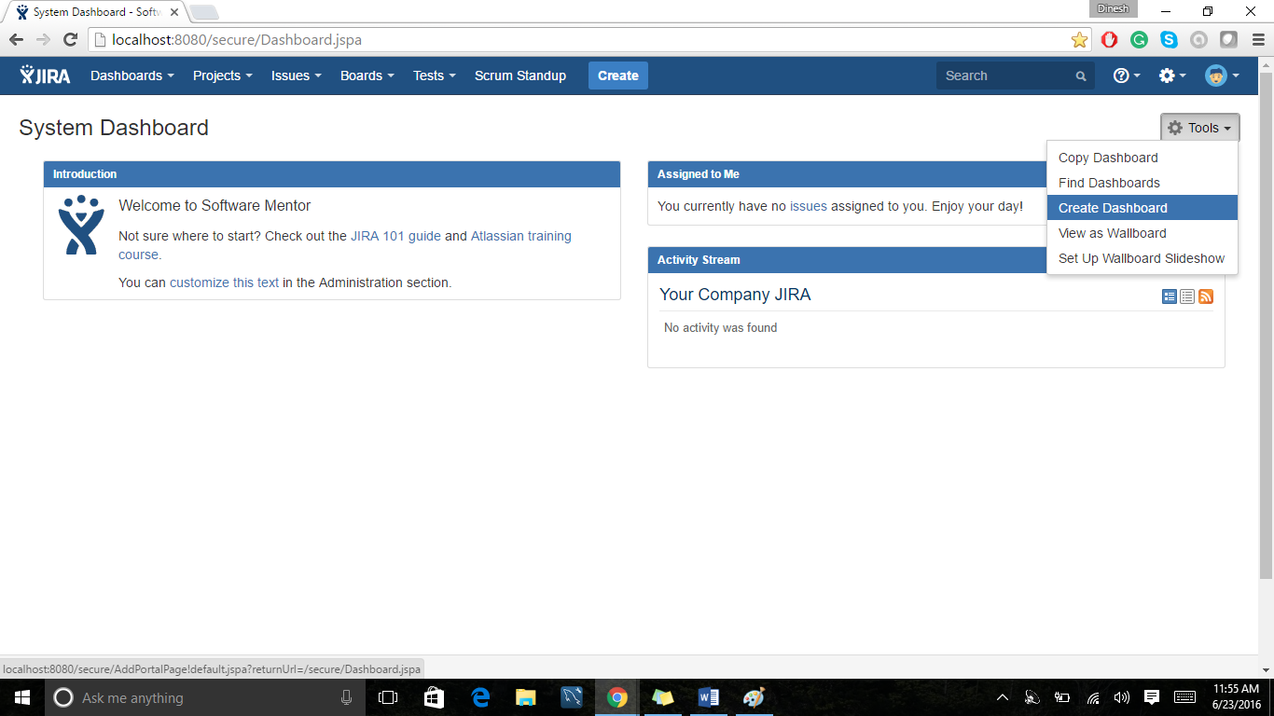

During the creation of dashboard, it asks for name of it, Description of it, start from- choose the specific one and I’m choosing blank dashboard and then important one with whom you want to share this dashboard. Please select one of the following options if you want to share the dashboard to the groups or users or projects or everyone and then select +add and complete the step. After creating the blank dashboard, it looks like, and then start adding the gadgets to your dashboard by clicking the +add gadgets button.

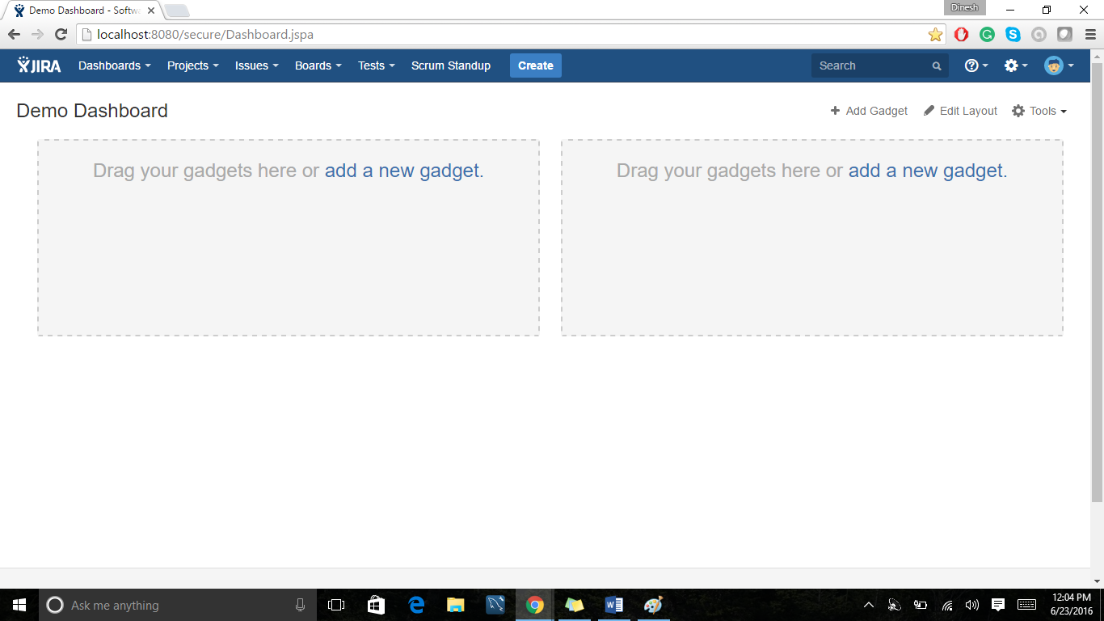

Click on the gadgets and choose according to requirement. I’m working with test execution process. After adding gadgets

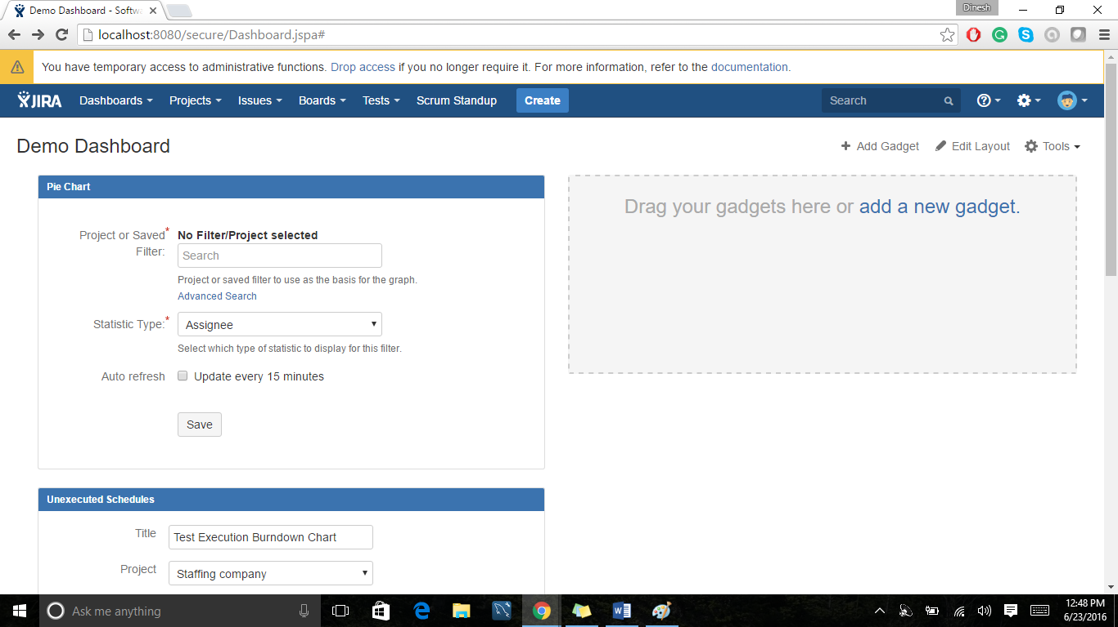

**Let’s learn how to write a Test cases in JIRA**

To write the test cases we need to select the project on which we want to work. No go to the Test tab click on it and select the create Test option. This will open a Test Template related to test case.

In this template you will be having many fields like Description, Summary, components, Priority, Labels, Due date, Assign to, Reporter, Epic Link (who works on Agile environment) etc. Once we provide all these details and click on the create issue button, a new Test Case page and redirects to the test case page.

So once Test case page is opened you can also perform the edit option to the test case which you created.

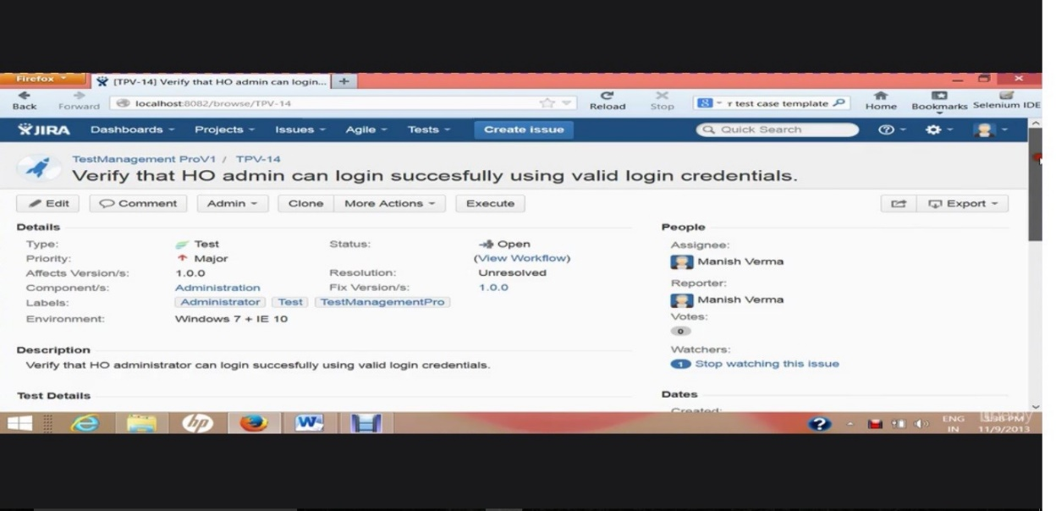

Here you can find Test Details tab where you can write

Test Step Test Data Expected result

Ex:

1. Open Admin Login Url: [www.testurl.com](http://www.testurl.com) The admin Login Page in IE 10. should be opened
2. Enter Login Credentials Username: user User should login

And click login button password: psw successfully

1. Now user should logout user logged out.

Let’s know about the clone feature and how the work load will be reduced using the clone feature in real time while working with Test cases.

Let’s work with this by working on the test cases which we created just now. From the Dashboard go to the Test tab on the Dashboard search for the test case which we have created just now. Once we select the test case and opens it the page will be redirected to the Test Case Page.

On the top of the test case page we can find the clone functionality button. The main feature of clone is we can clone the present test case into new one. Let’s discuss by taking one example.

Currently we are writing the test case for E- Commerce web site for both admin login and Member login. So in the both cases the functionality is similar that is the test has to performed to test the login functionality but for sure there are some changes to be made for both test cases like description of the test case, url of the page and some related information in test details. So instead of working with again and creating the new test case from scratch lets work with clone feature and make some changes in the test details. This will reduce the lot of work load.

Now let’s learn about searching test cases and performing bulk operations.

Here I will be explaining how to work with basic search feature of Jira and how customize it and how to perform the bulk operations.

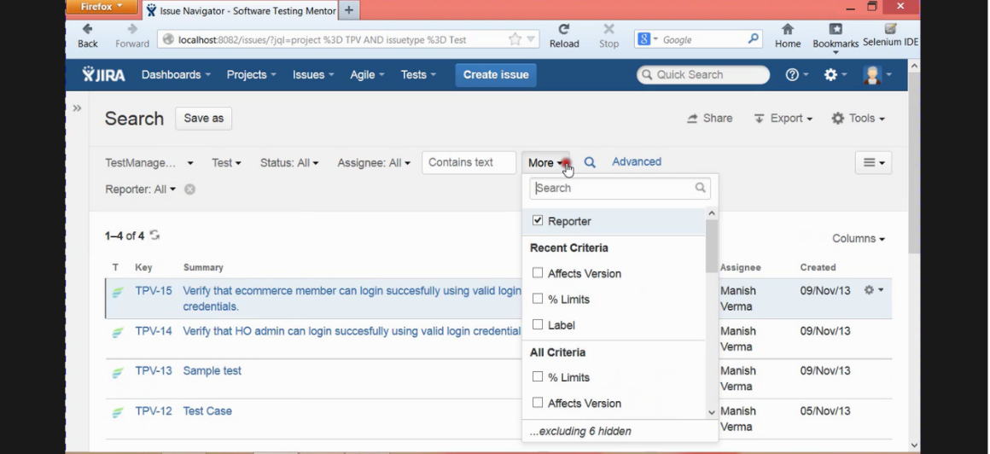

Please go to the project and choose the test tab and enter into it, it will show all the test cases under that particular project. According to the above image under TestMangementProv1 project there are four test cases available and we can search different test cases using the filters available below the search tab. To customize the basic search please go to more tab and add what are all you need to add then different filters will be added and can perform the search operation.

Now we will understand about the bulk operations when we have 100+ under one project. Go to the tools option which is present beside Export option and choose bulk operations. In the Bulk operations tab on the left hand side you can find four options

1. Choose Issues – we can choose any no. of similar issues like working with login operations for Admin login, User login
2. Choose Operations – Edit Issues, Move Issues, Transition Issues, Delete Issues, watch Issues, stop watching Issues.

We even get some notifications whenever changes are done for issues.

1. Operation Details
2. Confirmation

Let’s work with exporting the Test cases in JIRA

There are different exporting features of exporting test cases in JIRA. Go to the project for which you want to export the test cases.

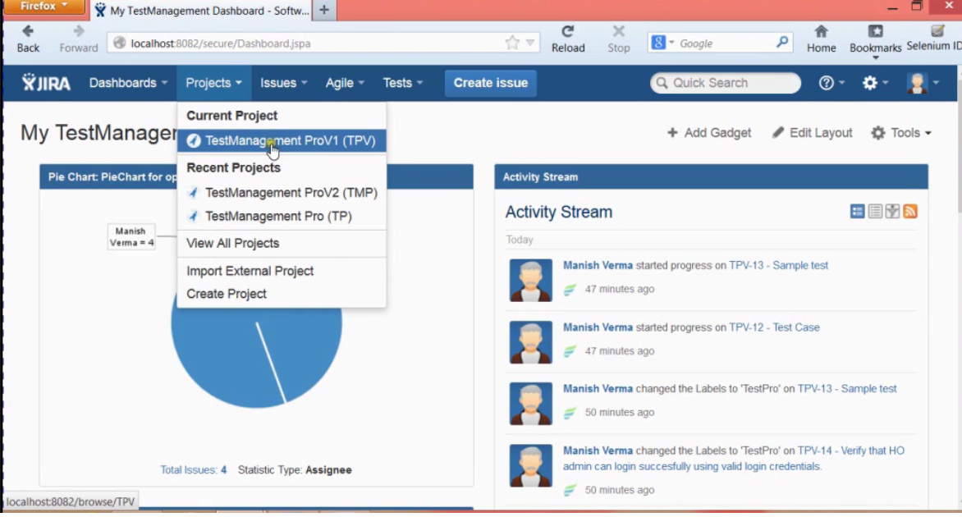

Then go to the Test tab and search all the test cases which you to export. Then go to the export button which is there are on the right hand side corner. 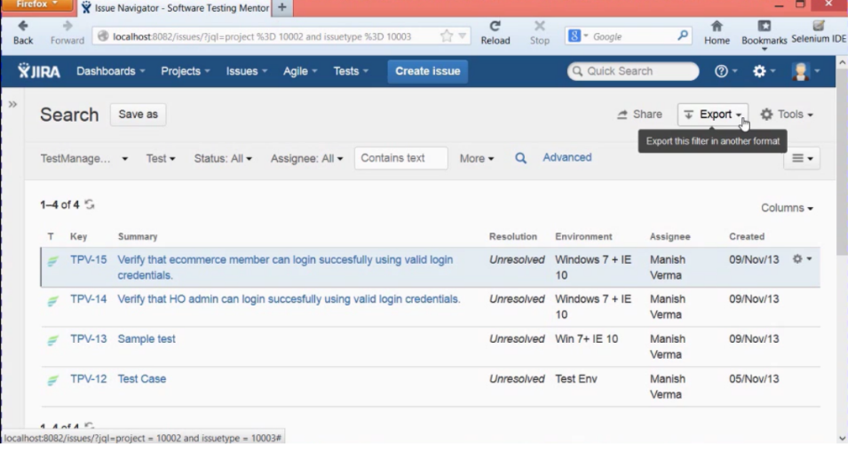

Click on the export button and you can find many options under export tab. They are Printable, Full content, XML, RSS(issues), RSS(comments), word, Excel, charts, on Dashboard. Let’s discuss about each option in details.

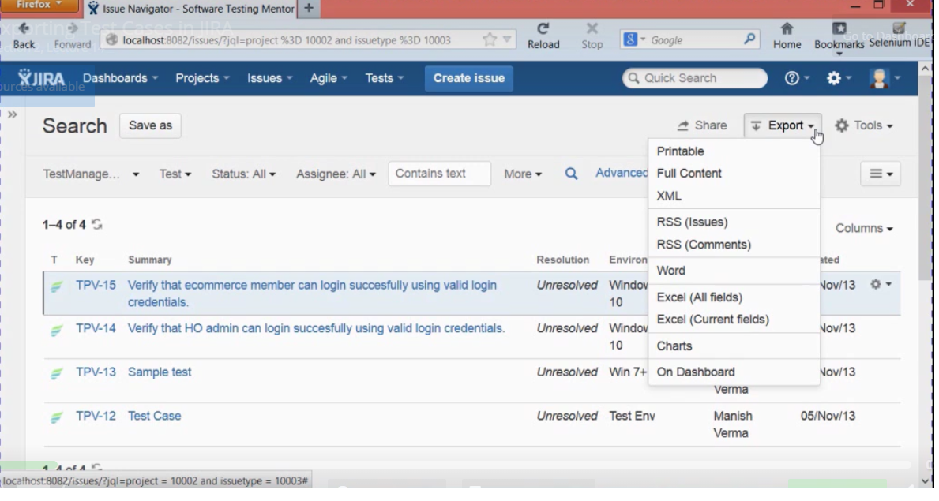

If we select the Printable option, it will show all the details about the test cases in tabular column and we can take a print of all these test cases.

If we choose Full content, then it will open the full content of the test cases in a web page along with test data provided.

If we choose XML, it will export all the test cases into XML format which will be useful to import them to another projects etc.

If we use RSS(issues) it will let us bookmark the test cases like a general bookmark feature of a web page. It shows all the test cases that you have selected and if the new test cases are added it will immediately reflect over the book marks.

If we use RSS(comments) in this, we get notified whenever someone comments on the test cases.

If we choose word option, then all the test cases with detailed information will be saved into the word file. Which will be useful to share to someone **“This is the benefit of working with test cases. We no need to invite someone to Jira to review the test cases. Word doc will contain everything”**.

If we choose excel with all fields it will make everything into excel format and excel field current fields will share the limited fields.

If we choose charts the test cases will be converted into charts and we can add it to the Dashboard and even the Dashboards option also helps us to add the gadgets of the test cases results to the dashboard.

Components are sub-sections of a project. They are used to group issues within a project into smaller parts. You can set a [default assignee](https://confluence.atlassian.com/adminjiraserver071/managing-components-802592503.html#Managingcomponents-default_assignee) for a component. This will override the project's default assignee, for issues in that component.

Let’s learn about Sharing the Issues and search query with the Team members.

Sharing the test cases with other team members is very important for a developer in real time also writing the search query for the test cases.

Why we need to share the test cases?

Sharing the test cases will help in getting the written test cases reviewed by the Team lead or team member. At the same time if we find any defects in the project then we need to share them to the developer to fix that issue and to re run the test cases to know it working perfectly or not.

To performing the sharing option, we need to search what are the test cases we are looking to share then select the test cases you are looking to share and then hit on the share button present on the right corner.

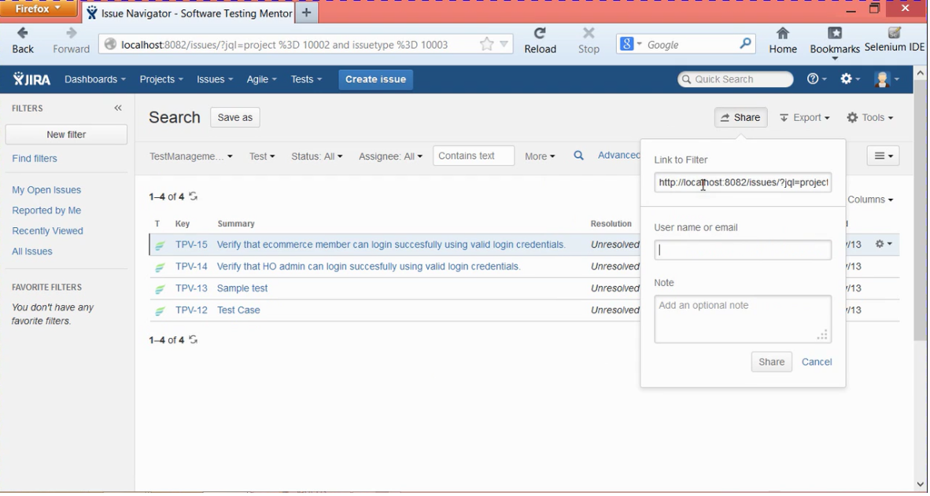

In the share option there will be default link for sharing the work and to please mention the user name or email Id of the person to whom we want share in a team a and also we can provide some note about the test cases like review the test case or fix the bug defect found etc., now the person will get a notification about the shared test case with link to click via email. Once the team member clicks on it, it will be redirected to test cases. In the above image the share option is performed for all the test cases which are present. To share one particular test case open that particular one and share it.

**Creating the Search Query**

Select the project and search all the test cases available under the project after that choose the different options under the different filter options like choosing the options from Test management, Test, assignee etc. and then save those settings. It will add these query under the favorite filter and you can share these filters to anyone in the team.

Creating Test Cycles in JIRA:

To create the Test cycle, go to the project and choose the Test cycle which is there on the left and choose the version of the project and click on the create test cycle option.

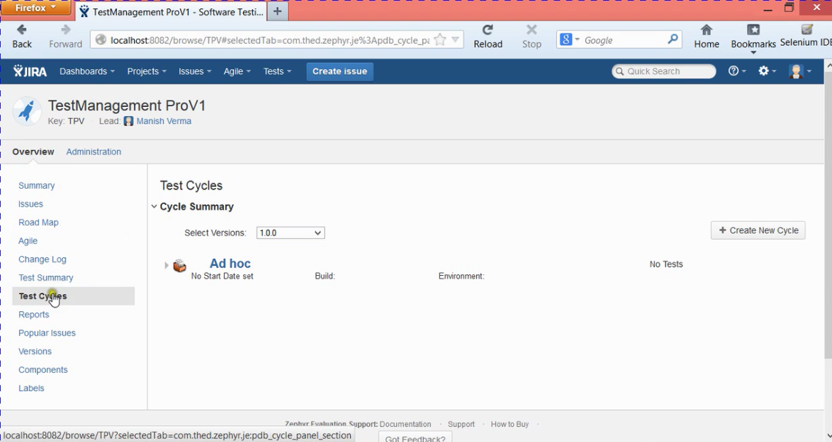

Once we click on the create new cycle,

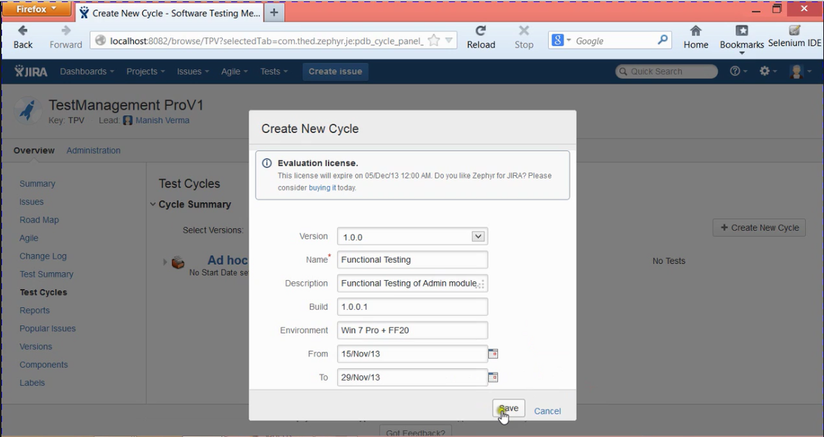

Once click on save, the test cycle will repeat from start date to end date.

This will add a new test cycle and now we need to add the test cases to it. To add it please follow the below image. We clone the cycle, export, delete, and add test cycle.

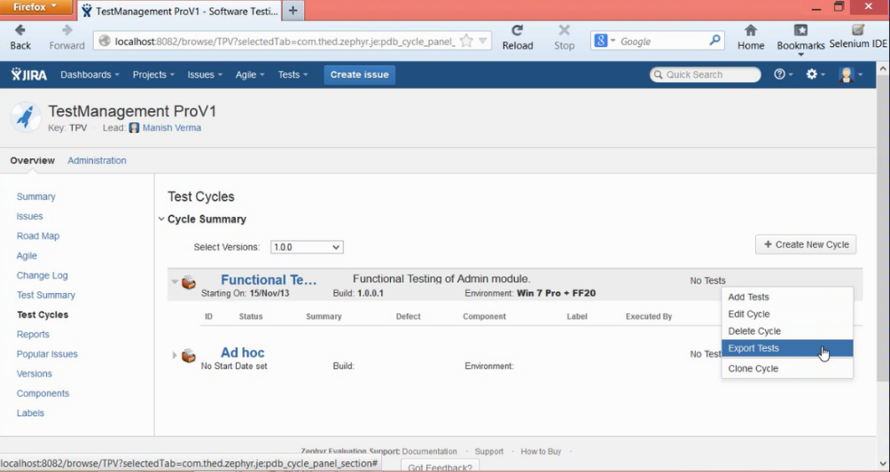

**Executing Test cases in JIRA**

Let’s learn how to execute the test cases. In order to perform the execute the test cases find which one you one to execute and open it and you find the execute button on top of it.

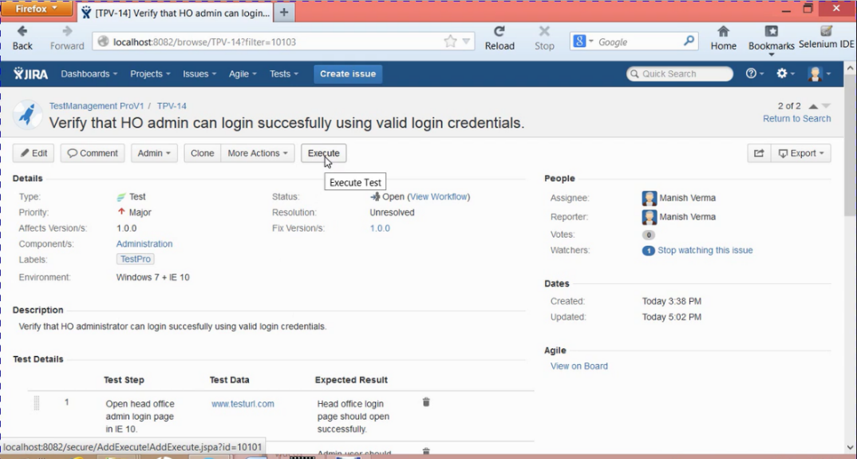

Once you click on the execute button it will open pop up with two options on it. One is Execute Ad HOC mode or Add it to Existing Test cycle and execute. Usually creating a test or adding it to the test cycle and executing is the best suggestion. But there some instances where we need to execute Ad HOC mode to execute one or two test cases.

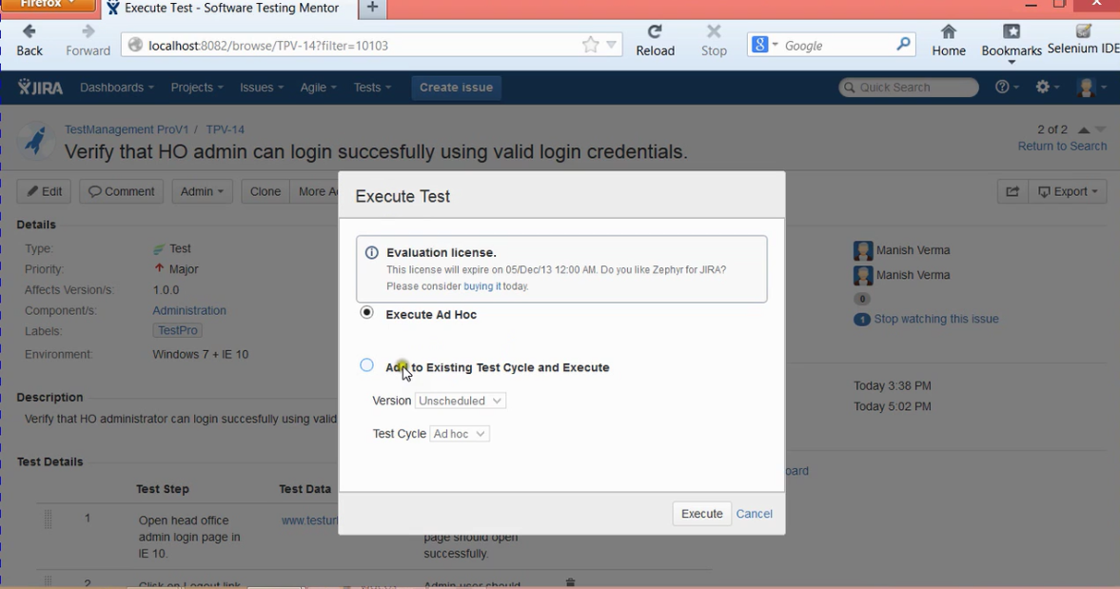

The most popular and commonly practice is creating a test cycle, adding the test cases and executing it.

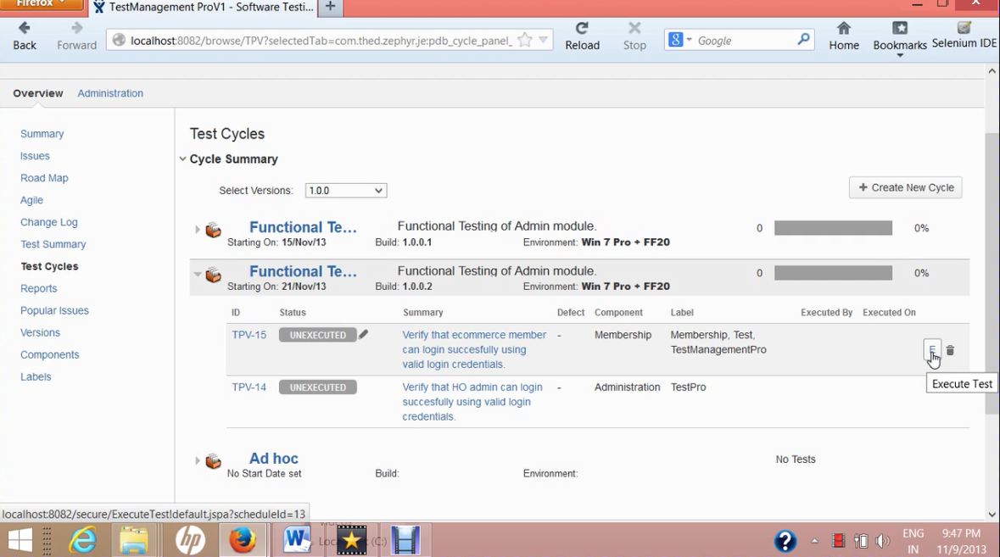

Click on “E” to perform the execution and it will open the Test Execution window. Under the test details we have to follow the step by step to change the process.

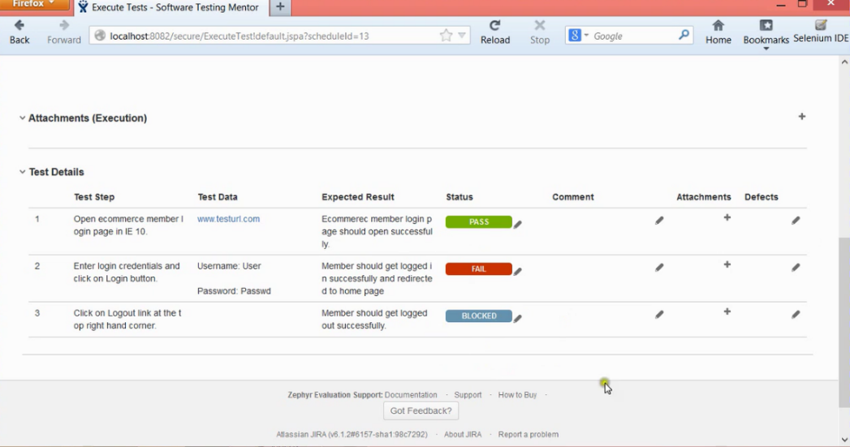

After executing all the steps, we have to go to the top again and mention whether test is passed or failed and mention the details

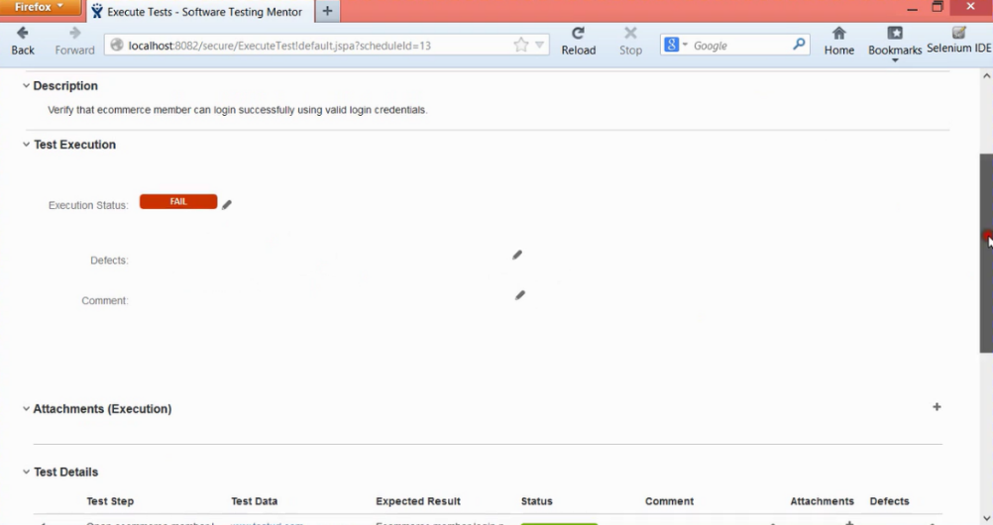

Now return to the test cycle page and we can see what is the is the status of the test cycle, who executed it and when etc.

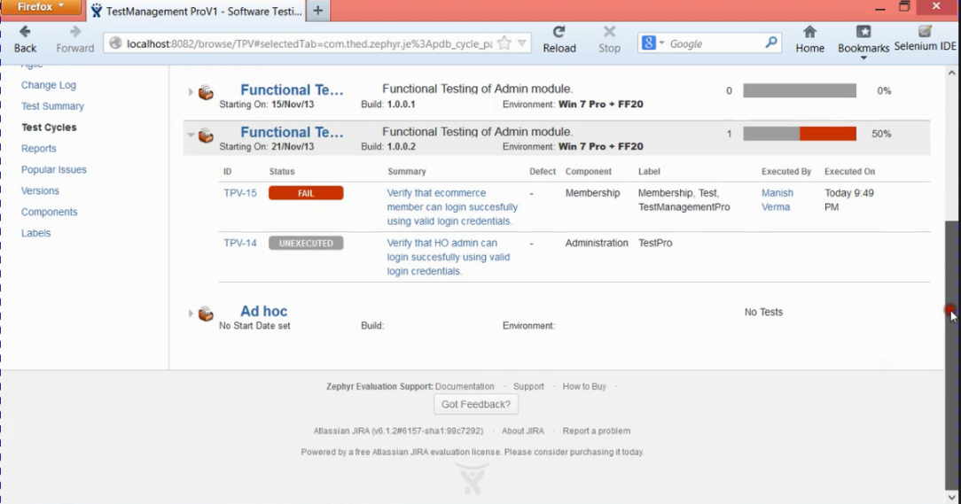

**Defect Management in JIRA**

Introduction to defect template in Jira

To create a defect, open the issues, and click on create an issue. This will pop up create issue tab here please do mention all the details. Important thing is as we are working with defects so the issue type will be BUG. And do mention description, attach screen shots of the execution process and do mention exact one like what kind of kind of defect it is either it is blocking the next levels to perform or high priority etc. and click on create. It will create a defect.

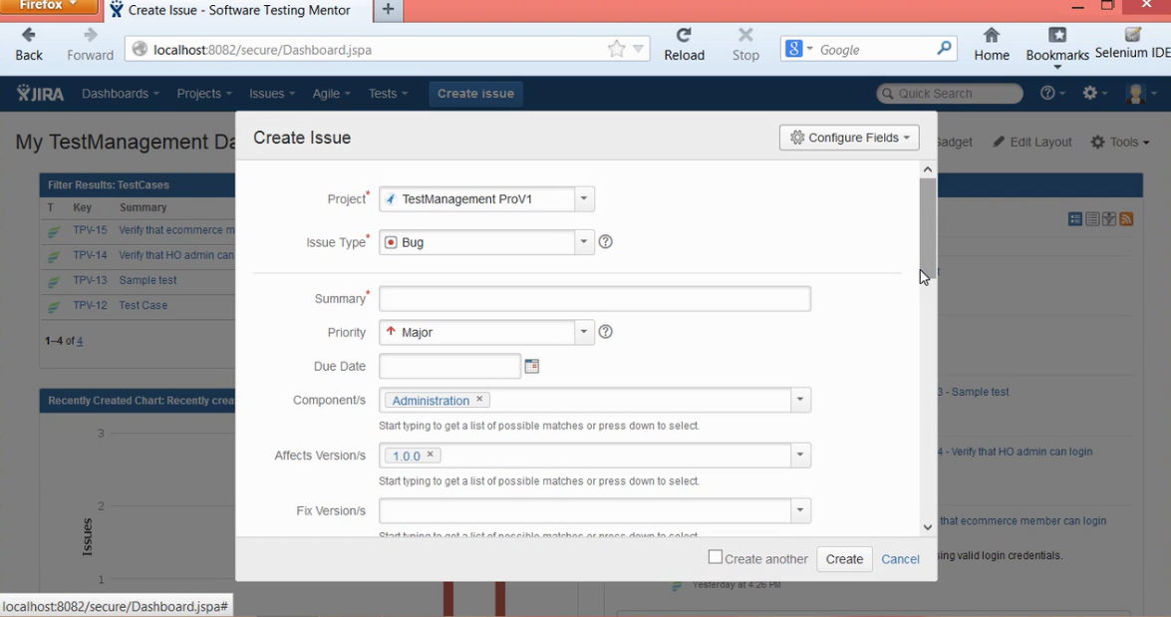

Logging defects in JIRA

How to log a defect or bug in Jira. To do this create an issue and issue type as BUG and fill out all the details and create a defect but the preferred option in raising a defect in Jira is got to the test cycle and perform the execution process and if some issue come then raise the defect.

So now go the test cycle and open it. It will open all the test cycles you have created in the past and choose one test cycle and try to execute it.

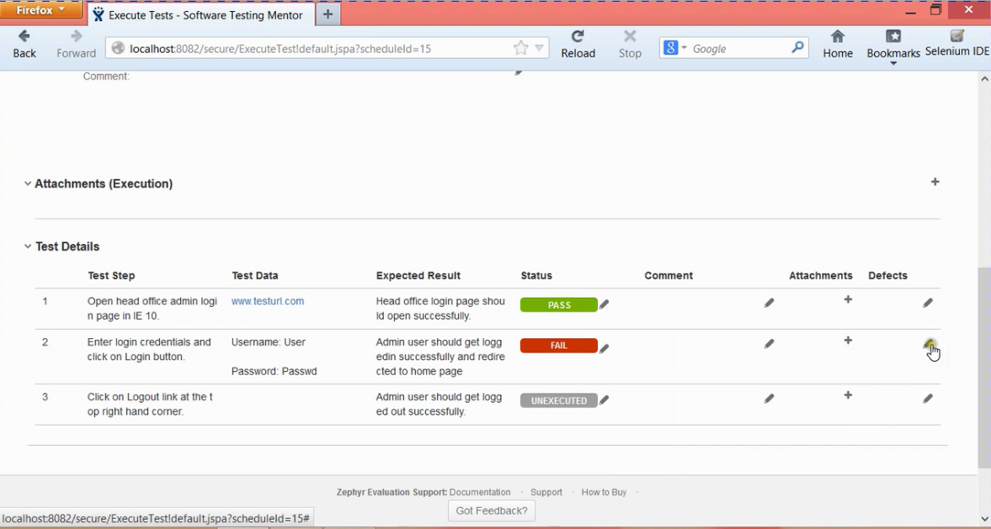

Please do mention all the details by clicking the defects edit pencil symbol and add an issue to it. After adding the defect, it will be

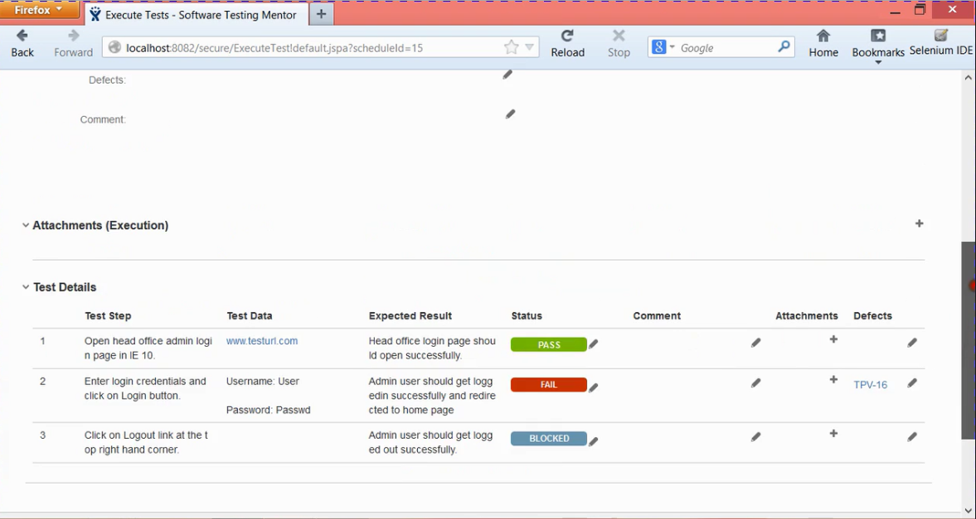

Once you perform everything and save it, go back to test cycle page and it looks like

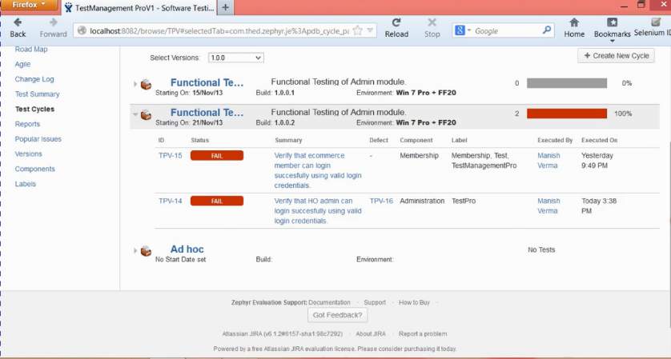

This is how the defects are created and if you can observe you find the defect mentioned under the defect type in test case and if you click on that defect it will redirect and show what defect is that.

Defect Life Cycle in Jira:

Once we log the defect it will go to defect life cycle process.

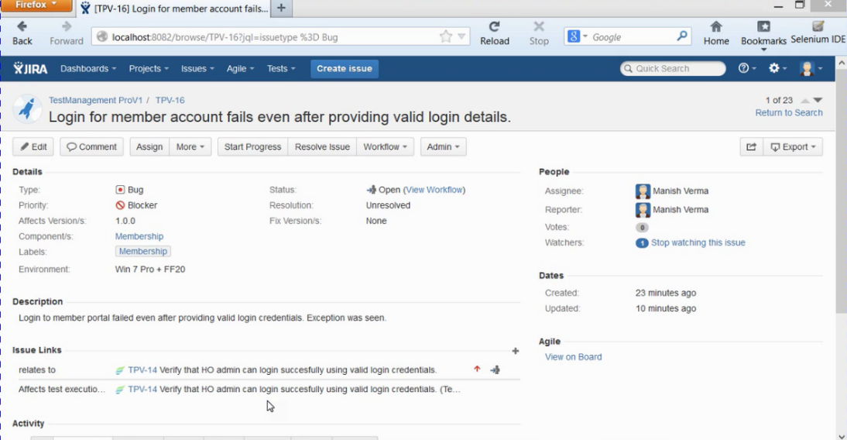

The life cycle is:

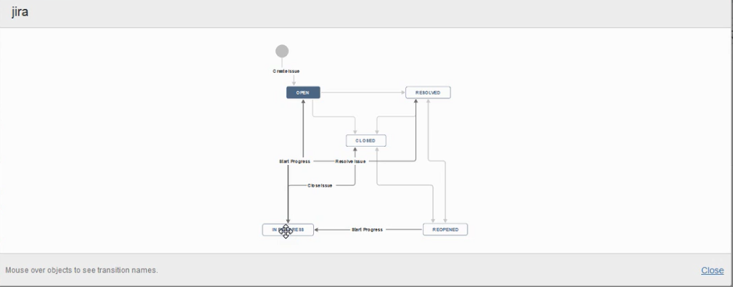

So once the defect is assigned to us and when we actually start working on it we need to click on start progress button so that the status of the issue will be changed from pending to in progress. So once we finished working on it we need to notify that by click on the resolve tab. It will open the Resolve tab to mention the details about the work done.

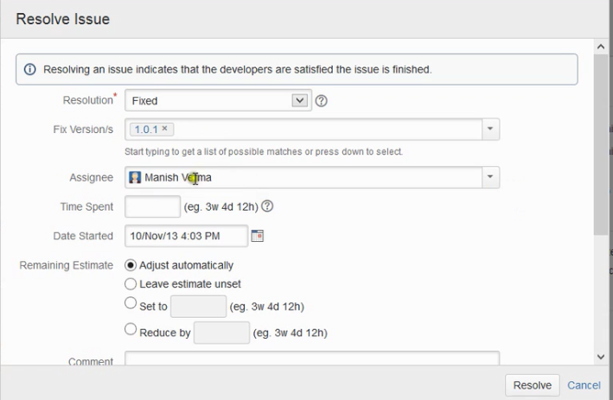

After providing all the details click on Resolve button. Now the issue status will be changed to resolved from under progress. Now the administrator will go ahead and search the resolved issues and select the issue which was recently modified and cross checks everything and closes the issue. When the Admin clicks on close issue, close issue window will pop up and need to mention and close it. A little appreciation will encourage a lot.

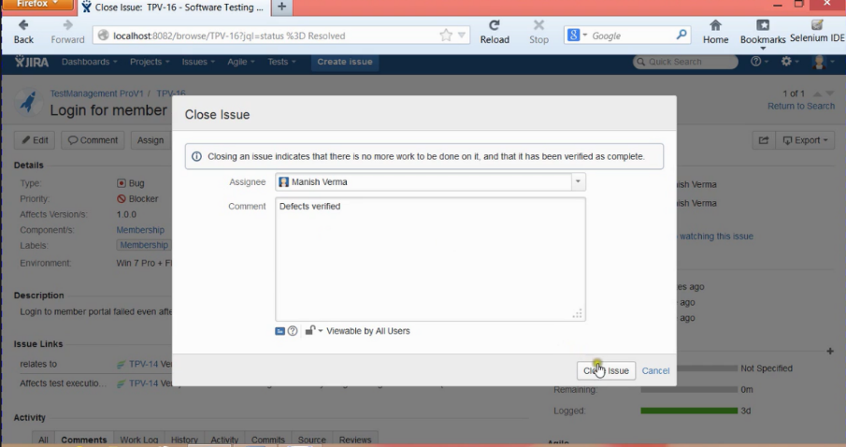

We can perform bulk operations, filters for the defects same like how we worked for the issues.

Advanced Search in Jira and Introduction to JQL

Let’s learn about JQL(Jira Query Language) and benefits of advanced search in Jira. JQL is the most flexible to search any kind of issue in Jira. JQL is similar to SQL and will be beneficial to everyone in the project. So it is somewhat easy for who experience on working with SQL.

JQL has three basic parts

1. The field
2. Operator
3. Value

And all these basic parts can be linked with the key words like AND or OR.

So without wasting any time let’s start working on it. So let’s launch the advanced search first. In order perform the advanced search go to issues and search issues then on the issues tab, the parts inside the rectangular box is for all basic kind of search. To perform the advanced search, click on the Advanced link.

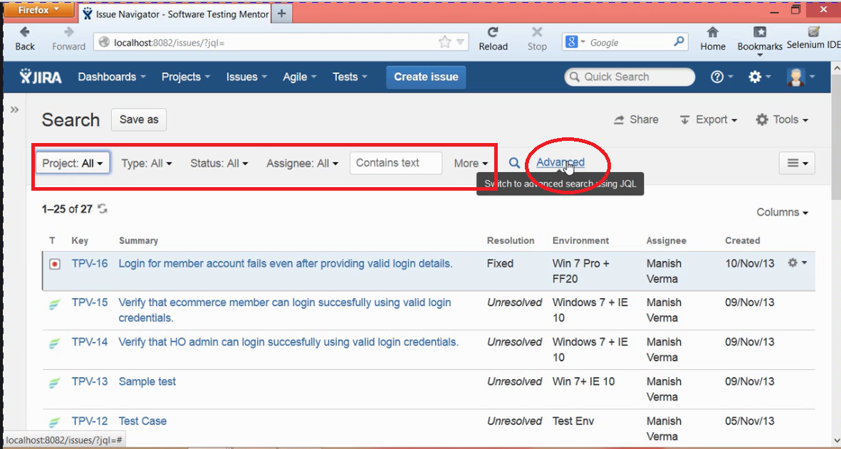

So once you select the Advanced search it will show the text box where you can write the JQL to search the issues.

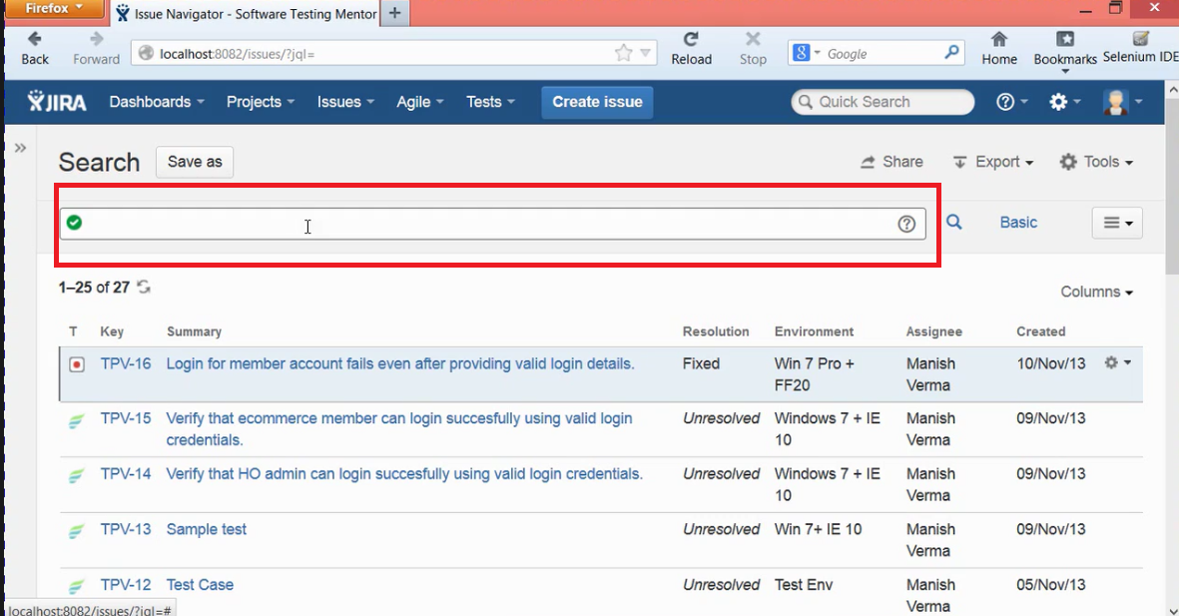

So the simple JQL query to search the issues that are created after 9th of November is

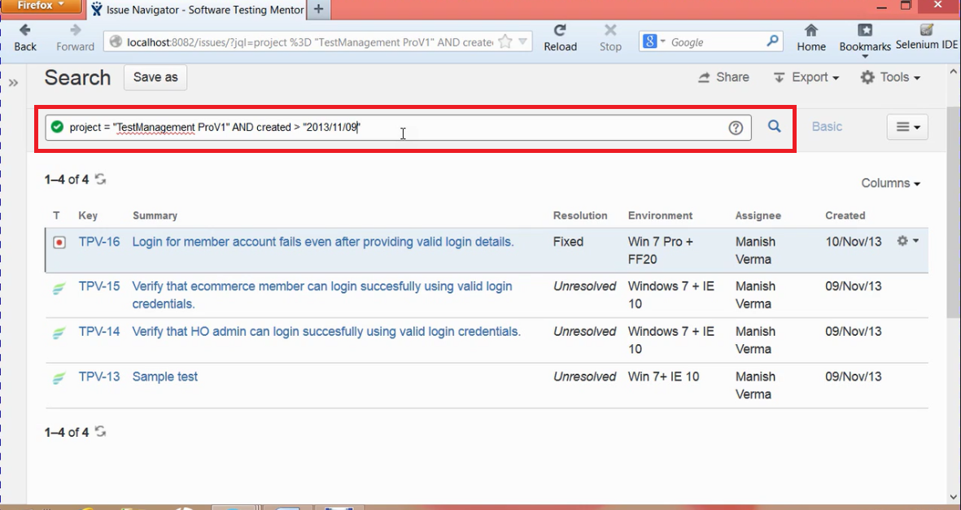

This will give you all the issues created after 9th November and the date format should be “yyyy/mm/dd”.

To search all the issues assigned to a particular person query is:

Project = “TestManagement Prov 1” and assignee = “Dinesh” and type = “Bug”

This will show all the issues that are assigned to me and selected type as bug to know how defects that are assigned to me. Instead of bug if we choose Test it will show all the test cases that are assigned to me.

Let’s find the resolved issues by my teammate manish:

To find this the JQL is

Project = “TestManagement Prov 1” and status = closed and assignee = manish

It will show all the issues closed by manish.

Let’s find how many issues were closed by total development team before 9th November to track the team status:

Project = “TestManagement Prov 1” and status = closed and resolutiondate < “2013/11/9”

It will show all the closed issues.

To specific persons closed issues before 9th Nov then:

Project = “TestManagement Prov 1” and status = closed and resolutiondate < “2013/11/9” and assignee = manish

This is how we write JQL in Jira.

**To Subscribe to the Defects:**

Create an advanced search filter and then save it. Now to get live updates about the issues go the mange filters and choose the specific filter and choose subscription.

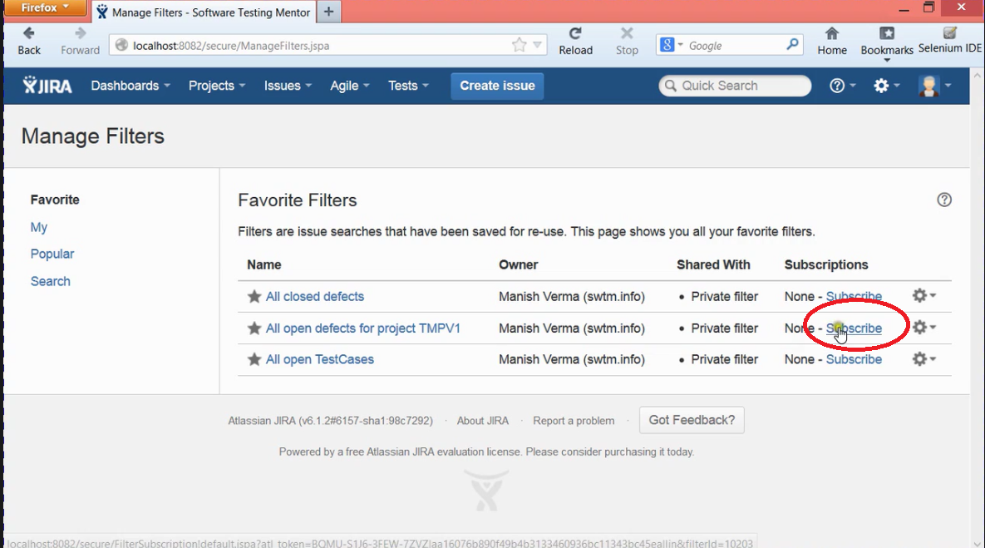

In the above image, I have created an advanced search filter for all open defects and clicked on subscribe button. Now the filter subscription tab will be open ask for the details.

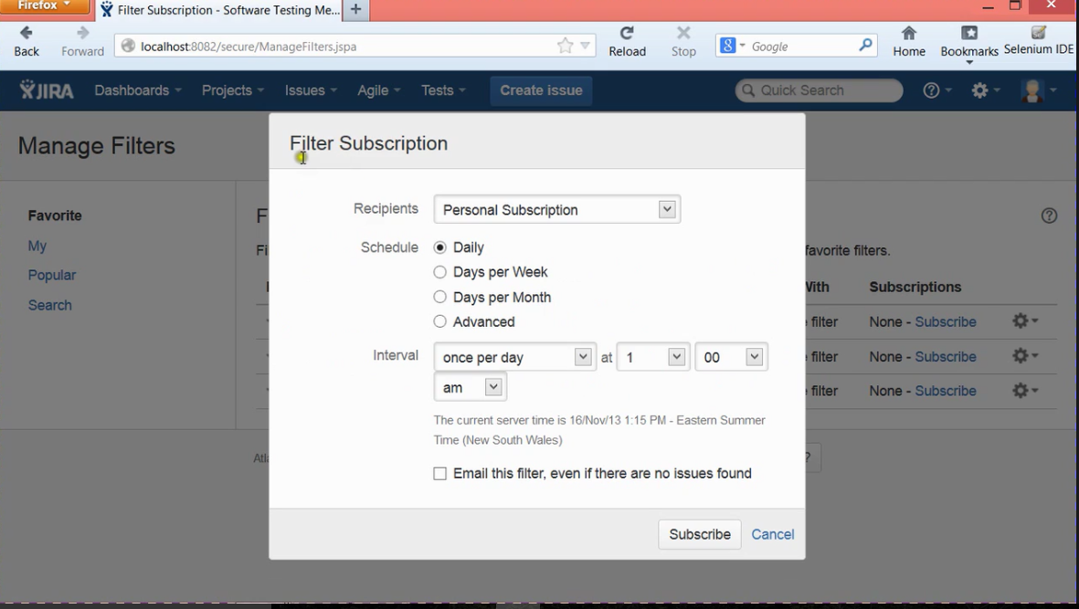

**How to Generate Reports in Jira:**

Generating reports is very important one when we are working with any tracking tool. This report will be having a brief info about the case. In order to start working with some of the reports that are available in Jira first we need to select the project and then under overview we can find reports.

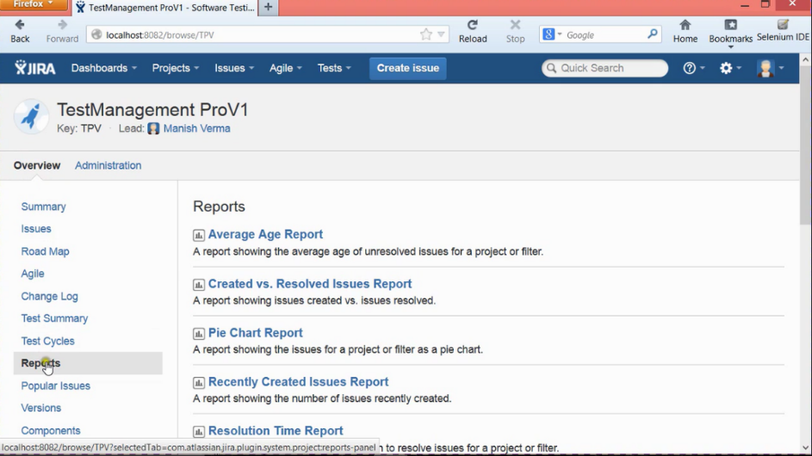

So it will show different kinds of reports available in JIRA with siple tag line about the report.

**Introduction to Jira Agile Boards**

Let’s a have brief discussion about Jira agile boards and what are the different types of boards available in Jira. Jira is a two types of boards supported.

1. Scrum boards
2. Kanban boards

Scrum board is for the teams who want work in sprints. So sprint is nothing but an Iteration and its time is 2 to 4 weeks where the developer looks to reach the working milestone in development process of the application. So each release will have 10 to 15 sprint cycles.

Kanban is new methodologies which works with “JUST IN TIME” concept. The best thing about Kanban is which will remove bottle neck problems like late submissions etc. and it is very suitable to the teams who works on defect management.

**Creating and managing scrum boards in JIRA**

To create a scrum board, go to the Agile tab and click on the manage boards option. It will open all the boards that are available and at the same time shows the option to create a board on the top right corner of the page. Select the scrum board

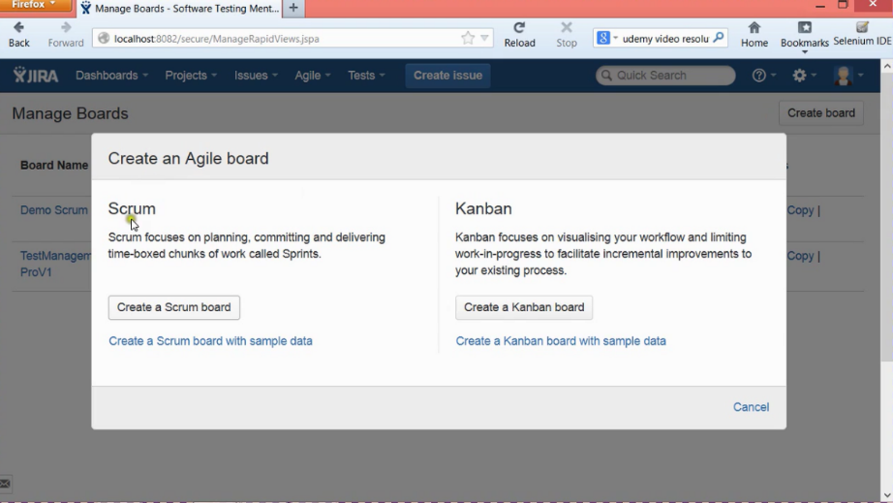

So once we click on create a scrum board then it will be redirected to next page giving three options

1. Create a new project and a new board
2. Board from an exciting project
3. Board from exciting saved filter

I’m working with create new project so once I select that option and click next then it will ask for Board name, project name and team lead.

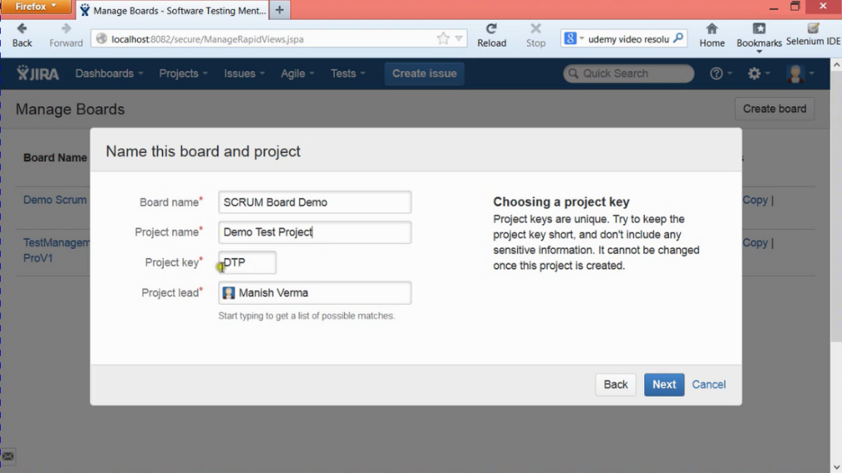

After this it will ask for work flow which is the final step.

1. Agile simplified workflow(Recommended) ------ I’m choosing this
2. Jira default work flow

After this board will be created.

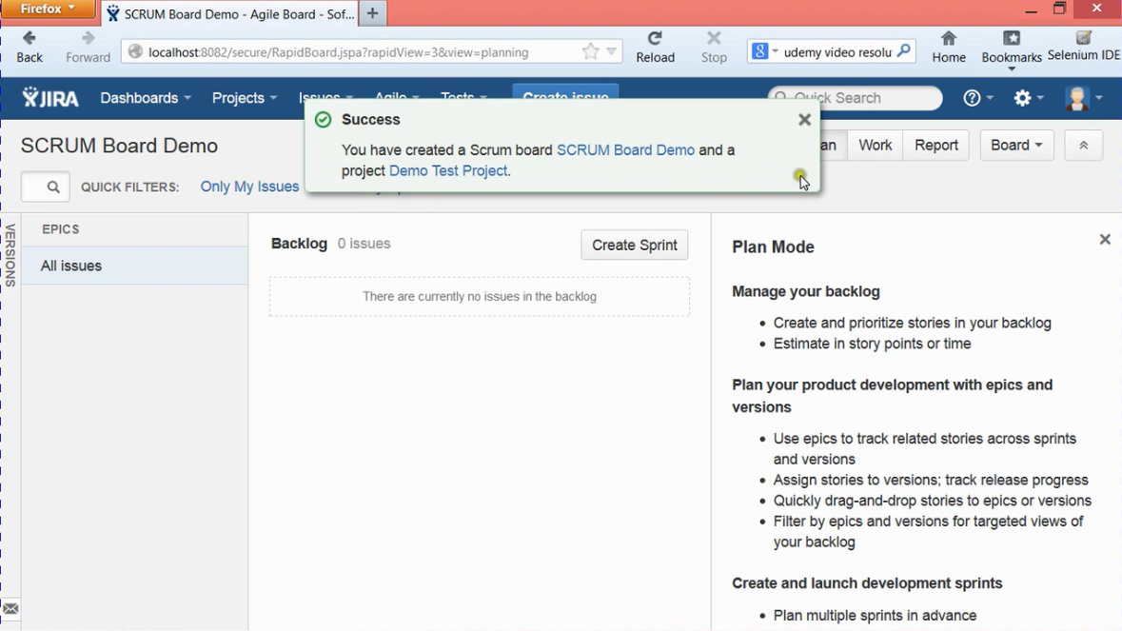

In agile development there will be a backlog and these backlogs will be moved to product to release. To create these, move your mouse on to EPICS and it will give us option to create epic. It will open create epic page were we can create these backlogs.

Now to create a sprint click on the sprint button it will automatically create a sprint. To add the the issues to the sprint drag and drop these epics. Now to start with the sprint click on the start sprint option.

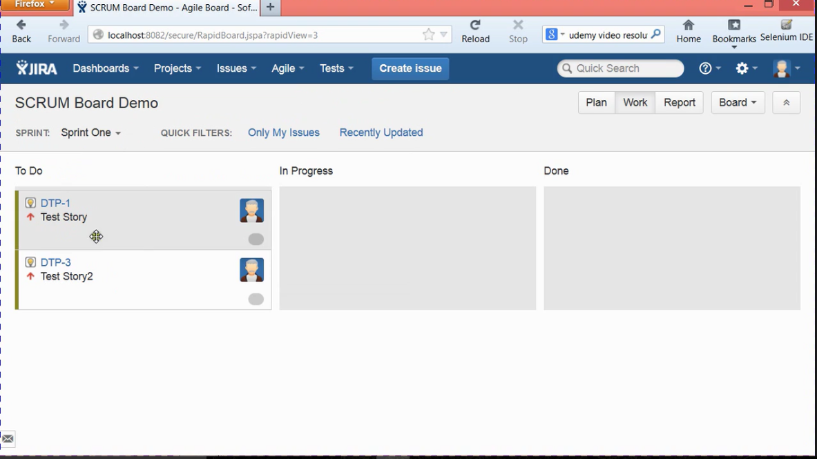

This is the sprint one with two to do stories in board. So depends on finishing the task drag the stories to in progress or done and close the sprint cycle.

Creating a Kanban board is very much similar to creating an agile board.

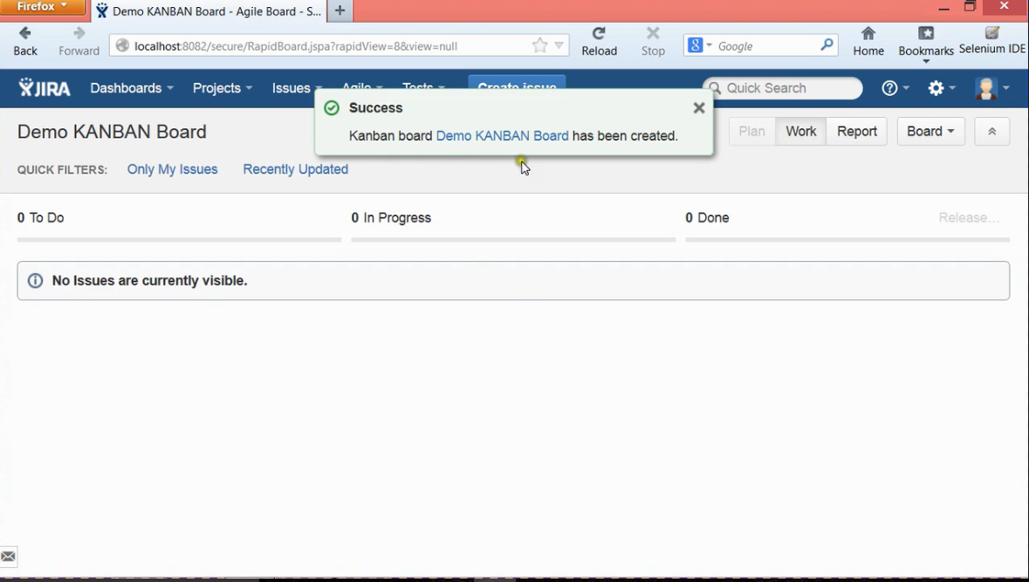

I hope I have provided an enough information about working with Jira to perform

* Test management,
* Defect management,
* Working with advanced search query,
* Working with reports
* Agile boards.

**Thank you**

**----Dinesh Boinapally**